PROJECT LOG

Design Sprint

Use this log to record your evidence

PRE-SPRINT

Investigate Relevant Conventions

Show evidence of
- investigating and applying relevant conventions

Basic Web Conventions

Visual Hierarchy

Design Style

Design Sprint

Phase 1 - Understand
Show evidence of
- describing the purpose of the outcome and the requirements of the end users

Unpack
Attach images, notes or recordings of the unpacking activities you choose to carry out

Value Proposition Canvas
Attach your completed Value Proposition Canvas here
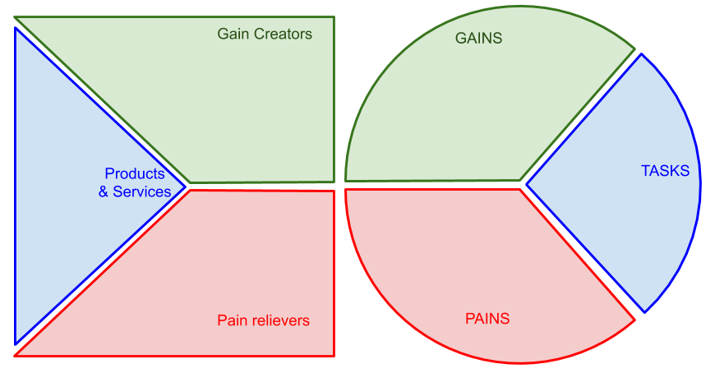

Problem Statement (POV - Point of View)
Attach your completed POV statement here
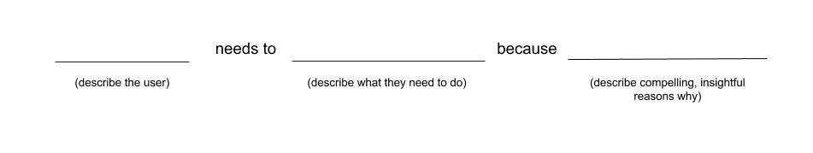

Phase 2 - Ideate
Show evidence of
- generating and modelling a range of design ideas

1 - Identify the conventions you will apply (20 min)
Record the 3 convention ideas you want to try
Attach images or links of the kinds of designs you want to try
Record any group discussion you had

2 - Doodle Ideas (20 min)
Attach images of the doodles you created. Include upvotes, stickers or comments from the group

3 - Crazy 8s (8 min)
Attach your EIGHT crazy-8 designs

4 - Solution Sketches (30+ min)
Attach your THREE wireframe sketches (drawn by hand or using a wireframing tool)
Make sure you label conventions you applied

Phase 3 - Decide
Show evidence of
- explaining relevant implications
- selecting a design for the purpose of the outcome and explaining the appropriateness of the design
- explaining how the chosen design uses appropriate conventions (Merit)
- justifying how the chosen design addresses implications, end-user considerations, and uses appropriate conventions (Excellence)

1 - Relevant Implications

Implication | How relevant is it? | Explain what the implication is and what it means  Why is it relevant to your design?  How will it affect your design?
social
cultural
legal
ethical
intellectual property
privacy
accessibility
usability
functionality
aesthetics
sustainability and future proofing
end-user considerations
health and safety implications

2 - Make a decision

Team Discussion
Attach notes or audio recording of your team meeting here
Make sure every member of the team has contributed

Decision
Record what your team decided here. This should include the design(s) chosen

3 - Explain and justify your decision
As an individual explain and justify (give reasons and evidence for) your team decision
You should refer to the team discussion above for evidence

Explain why your chosen design was the most appropriate for the purpose and end user
Explain how your chosen design addresses the most relevant implications
Justify (give reasons and evidence) how the chosen design addresses implications, end-user considerations, and uses appropriate conventions

Phase 4 - Prototype
Show evidence of
- Applying relevant conventions
- Modelling design ideas

1 - Generate a prototype
Attach your ‘prototype’ design here
It should be functional enough to allow users to give feedback on all aspects of the design
Where possible label your design to explain how you used relevant implications and what conventions you are applying.

Phase 5 - Test and Refine
In this section you need to show evidence that you
- used feedback gained from modelling to improve the design (Merit)
- developed an informed design (Merit)
- developed a refined design (Excellence)

1 - Get Feedback
Record all feedback you received here.
Attach audio files or screencasts, written feedback or annotated images (pictures labelled with feedback)
Add a comment next to any feedback that informs changes to your design

2 - Research
Attach links and screenshots of relevant research here
Make a note of how this informs your design

3 - Refine
Attach the new, informed version of your prototype here
(Changes can be shown by annotation, notes and scribbles as well as by actually changing the prototype)
Make sure you show evidence of how you improved your design in response to feedback

4 - Explain changes
Change(s) made | Link to feedback that informed the change  How change helps to address relevant implications, end-user considerations or use of conventions

Add rows as appropriate

POST-SPRINT

Design Sprint Review

This is your last opportunity to show evidence of you
- Using feedback to improve the design
- explaining relevant implications.
- explaining how the chosen design uses appropriate conventions
- justifying how the chosen design addresses implications, end-user considerations, and uses appropriate conventions.

Attach your interview notes or audio here

