Why data merge?
If you want to create a number of documents with the same layout but different content, it may be easier and less time-consuming to create a template in Illustrator and then “fill” in the placeholders with data from another source. A good example of this would be if you were doing 100 name tags, and each name tag had the same layout, with a background image, logo and border, but a different name and photo. You would create the template with the background image, border and a placeholder name and image. Then you would data merge in the names and images to create 100 individualised name tags.

Illustrator and InDesign both data merge documents. InDesign will data merge into one document, whereas Illustrator is a little more complex and will data merge individual datasets and you then have to batch process the result into separate documents which are exported as PDF files. This is because Illustrator does not do “multipage” documents like InDesign does. Both processes have their advantages and disadvantages.

This resource will take you through both processes and you can choose which software you prefer and which suits you best. If you want separate files for each output, then Illustrator will be best. If you want one file that contains all the documents, then InDesign is best.

Skills you should have before starting this:
- Be confident using a spreadsheet to enter information (no formulae required)
- Save a spreadsheet as a .csv file
- Work with text and images in Illustrator
- Creating paragraph styles in Illustrator

Illustrator data merge:
Steps you will go through:
- Create template
- Set up source file and save as .csv
- Import the source file
- Bind each variable to an object
- Preview each dataset
- Export the files using actions.

Here is the interactive PDF with screencasts

1.Create a template
You need a template for your design before you start. The template will have the elements of your final document that are both constant (will stay the same across all documents) and dynamic (will change in each document).
Each element of your document that is dynamic will need to have a corresponding element in the data source. You need to make sure that when you are creating your template, you are thinking about the information that is going to go into the final document, and making sure that you take note of what needs to go into your data source document to populate your final document.
A template in this instance is just a new document. Go to File > New and click on Create New. The following Dialog box will appear.
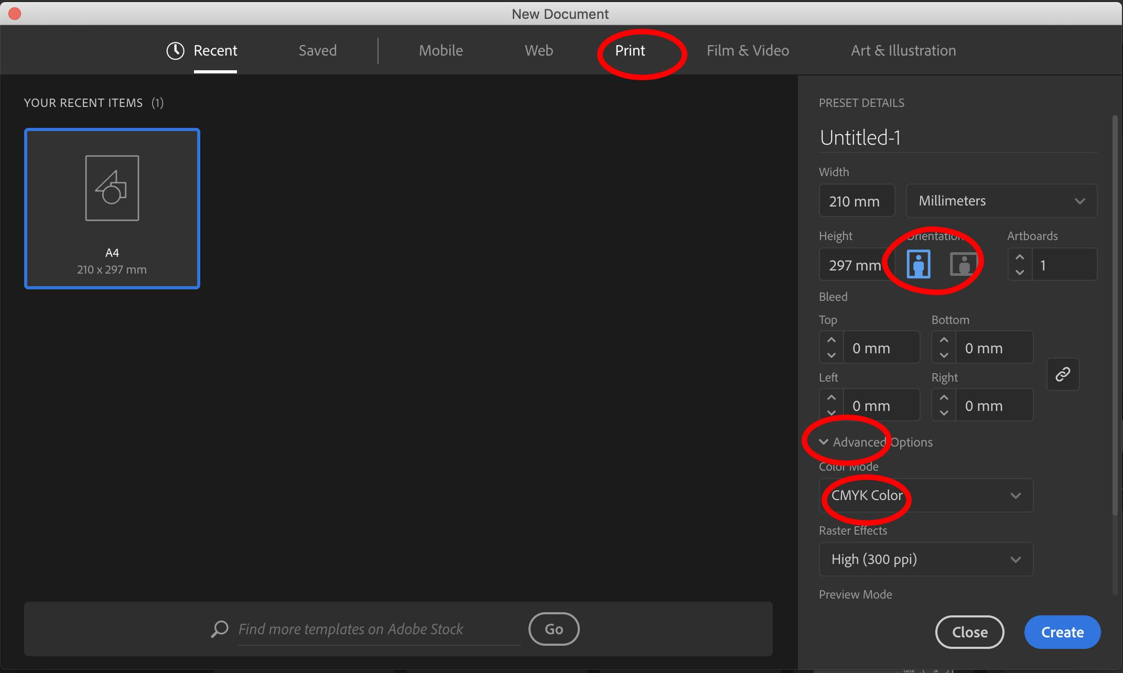
Choose Print from the selection at the top, and then enter your dimensions, or choose from the preset A4, A3 etc.
Check that your document is CMYK colour mode. If it isn’t, click on Advanced, and choose CMYK from the dropdown menu. Then select Create Document.

Your students will go through the design process and get to a final design from which they will create a template (or their final design will become their template if their design process is digital). Images will be place-holders, and textboxes will be set up with paragraph styles and dummy text.
Anything that is constant on each document can be created and put into the template.
For example, on the template below, the “Contact Us” is the same on every document, and the brown and black panels are the same on every document. The rest of the text is dummy text, with paragraph styles created and applied.
Once you have created your document, go to File > Save As > Template

Illustrator template example:
Note that Illustrator needs you to have placeholder images and text inserted.
Source: Illustrator software
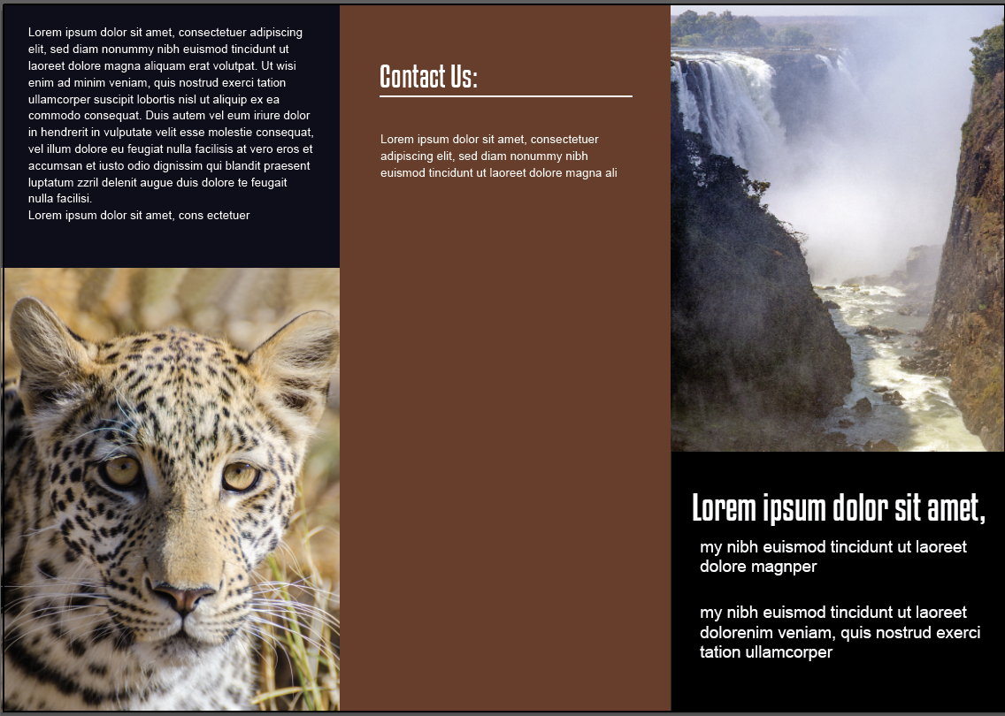

2. Source file
The source file contains the data and images that will go into your documents. For the purpose of this example, I am creating a spreadsheet, and saving it as a .csv file. You can do an XML file as well, but I prefer to use a .csv file. To create a .csv file, just make a spreadsheet (Excel or Googlesheetss will both work) and Save as (Excel) or Download as (Googlesheets) .csv (comma separated values).

Your spreadsheet needs to have headings in cells across the top that will correspond to any fields/placeholders in your template.
For example, if you have three text boxes that need text filled in your template, you will have three columns in your spreadsheet, appropriately named according to the text they contain.
Eg “companyName”, “companyAddress”, “smallBlurb”
For any images, you need to have the full filepath typed into the cell. The filepath is the place or location of the image file on your computer. It tells Illustrator where to find the image on your computer, what folder it is saved in, where it is located and what it is called.
Image columns must start with the @ symbol eg @mainImage.
Illustrator will show you what the filepath is for your images.(see screenshot below)
Go to File > Place and place an image from the same folder that you are keeping all your assets in. Then go to Window > Links and it will show you the links panel.Illustrator will show you the full file path, and you will need to type it into the spreadsheet.
Don’t worry about getting all of your different data for every document to look good in the template before putting it into the spreadsheet. That defeats the whole purpose of the data merge. Once you have the data put into the data source, and you create the data merge, you can preview each dataset individually before you actually make the final merge. This final step means that you can go back and make any changes to your layout and information before committing to the data merge and exporting your files. You can re-link your data source at any time, which means that you can make changes to the amount of text in there, save it and re-link, then do the data merge again and preview the data sets before committing to the final data merge and exporting the files.

Illustrator image filepath:
Go to Window > Links and then click on the down arrow underneath the bottom image to open up the dialog box under the list of images that are linked.
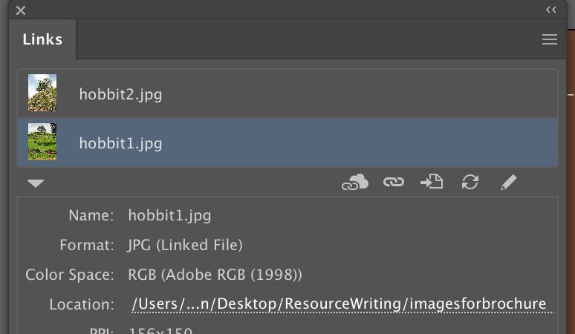
The Location shows the full filepath that you need. You may need to drag out the box to see the entire filepath. You need to type this filepath into the cell in the source file.

Setting up your source file:
Each heading in your spreadsheet corresponds to a piece of information (text or image) that will be in each document you are producing. The headings in your spreadsheet must have no spaces. For example, for “mainimage” you cannot have “main image”. It needs to be “mainimage”, “mainImage”, “main_image” etc. Any spaces in the heading names will result in the import failing in both InDesign and Illustrator.
If you are using images, then you need to begin with an @ symbol in your heading. Some spreadsheet applications do not like this, so you need to put a single quote in front of the @. So, mainimage becomes ‘@main image. The @ symbol tells Illustrator that it is a graphic. (note the single quote in the formula bar. It doesn't show in the cell itself.)

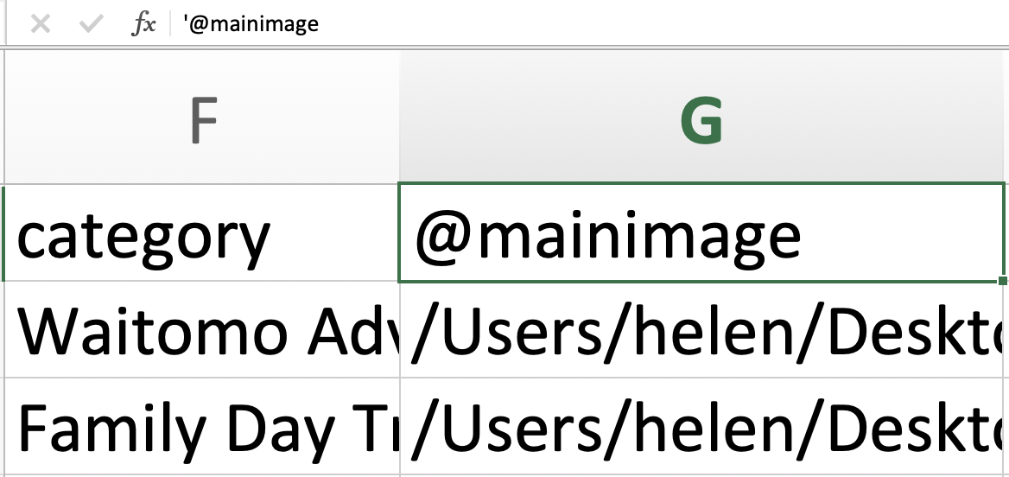

Put the information that you want for each document into the spreadsheet. Each row corresponds with a separate document. So, if you have 12 documents that need to be created, you will have 12 rows. For the sake of this example, I will call each document a record.
Do not have any empty columns in your headings. If you have an empty heading column, then Illustrator will tell you that your csv file “is not valid” when you try to import it. It is OK to have empty columns in the records. Eg if you had two address lines for one record, but only one address line for another, have two address lines in the headings “Address1” and “Address2”. Then in the record with only one address line, you can leave the second address column empty.

Once you have populated your spreadsheet with the data you need, save it as a .csv file.
Neither Illustrator nor InDesign like it if the spreadsheet is open when you do the data merge, so make sure that you close the spreadsheet once it is completed and saved as a .csv file.

For this example, I only created two records, so my csv file had only two rows under each heading.
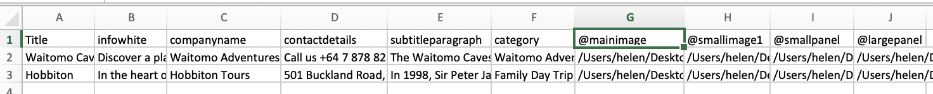
Now, you need to make sure that your template and the source file will “marry” up together.
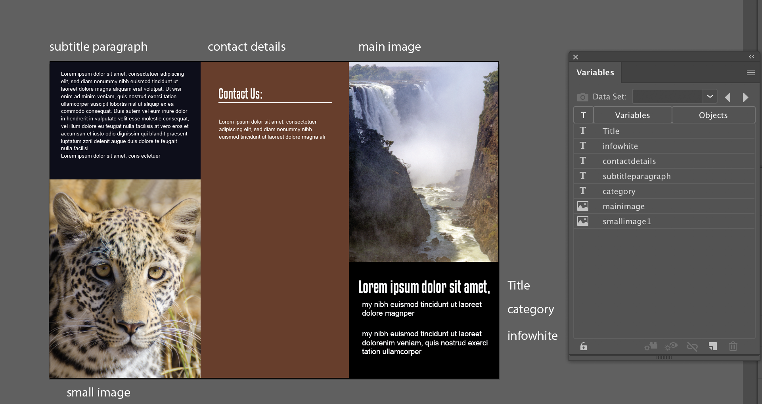

3. Importing the source file:
1. Open the variables panel Window > Variables.
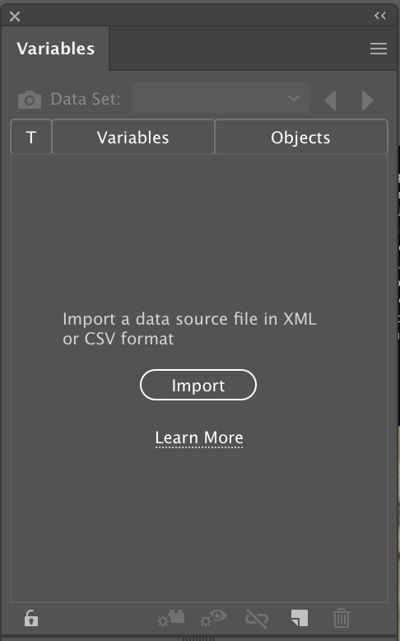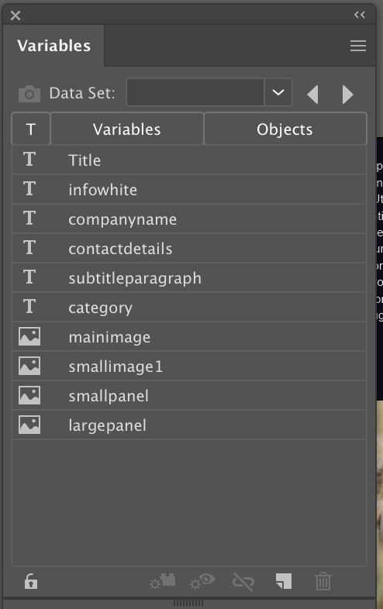
1. 2.
2. Click on import and select your .csv file. The cell headings that you used should appear in the dialog box.

4. Binding objects to variables
Now you need to bind the variables to the object on the template. This means you select the image or text box on the template, select the name of the variable on the panel, and then click on the “make linked file dynamic” icon at the bottom of the panel. Once you have bound a variable to an object, the name of the object it is bound to will appear in the Objects column.
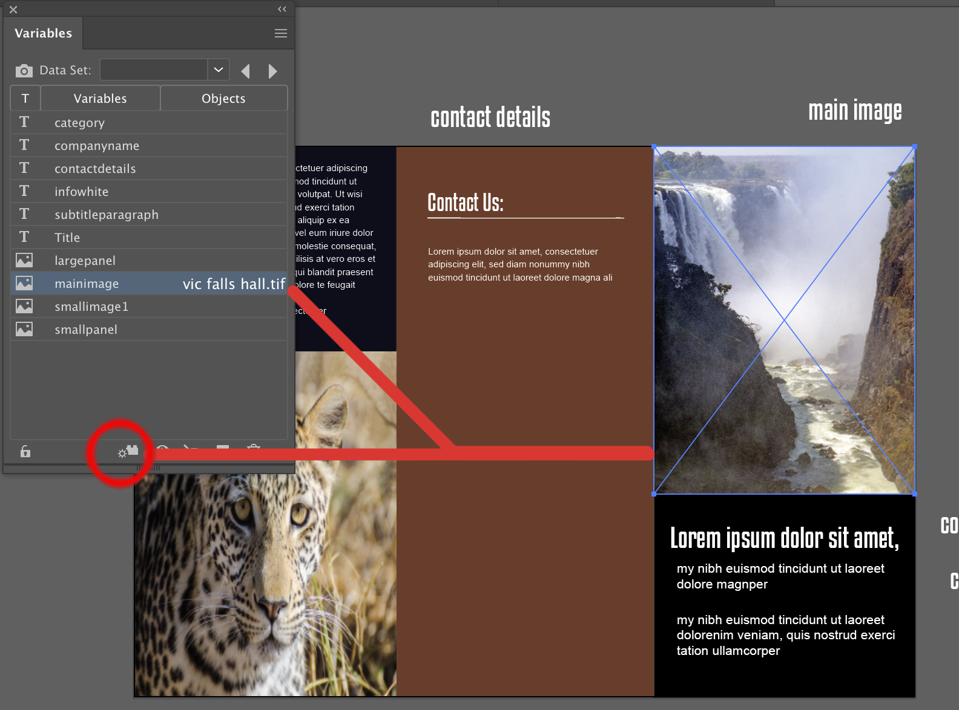
Do this for each element in the document that needs to be dynamic. When you select text, the icon at the bottom of the panel will stay the same, but the wording will change to “make text dynamic”.

5. Preview each dataset
Once you have completed all of the dynamic items, you can click on the “data set” down arrow at the top of the variables panel (to the right of the camera icon), and scroll through each version of the document. Each dataset will give you a different version of the document, according to the data that is in the spreadsheet source file.
Check that each dataset looks correct. You may need to adjust some of your text settings, or increase the size of text boxes if text doesn’t fit.

6. Batch process your datasets
Once you’re happy with how your datasets are looking, you need to batch process your file to save each document individually.
Illustrator will save the files as PDF.
Create a new folder where you want the PDF files saved and name it appropriately.
Create an action to save your file:
Go to Window > Actions, and in the submenu in the top right corner choose New Action.
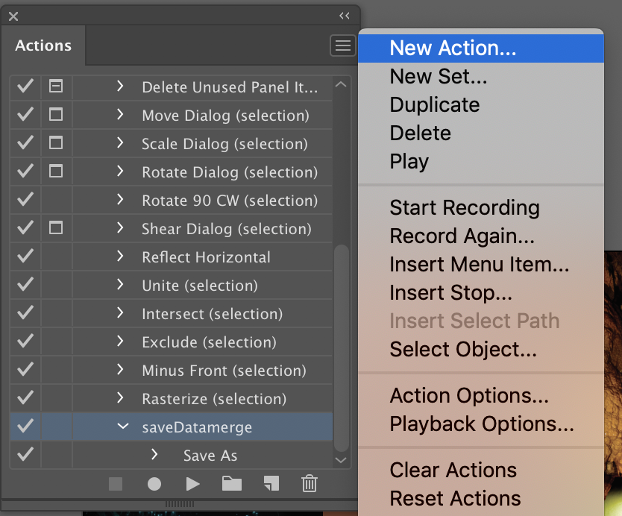
Give your new action a name, such as “Savedata merge”.
Start recording.
Go to File > Save and give your file a name. Then press the stop record button. You will see your action appear in the list of actions. Select it by clicking on it.
With your action selected (it will be a pale blue colour), go to the submenu again, and choose “Batch”.
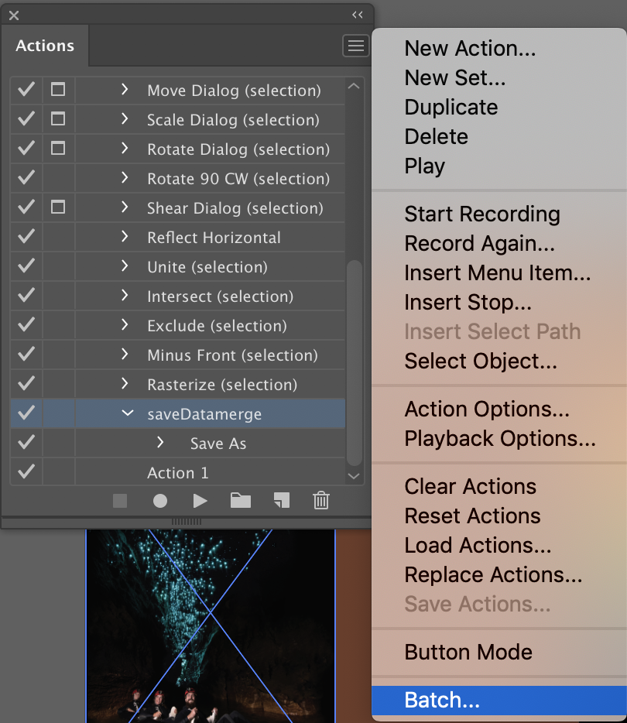

You will get a new dialog box.
You should make sure that you select the following (circled in red):
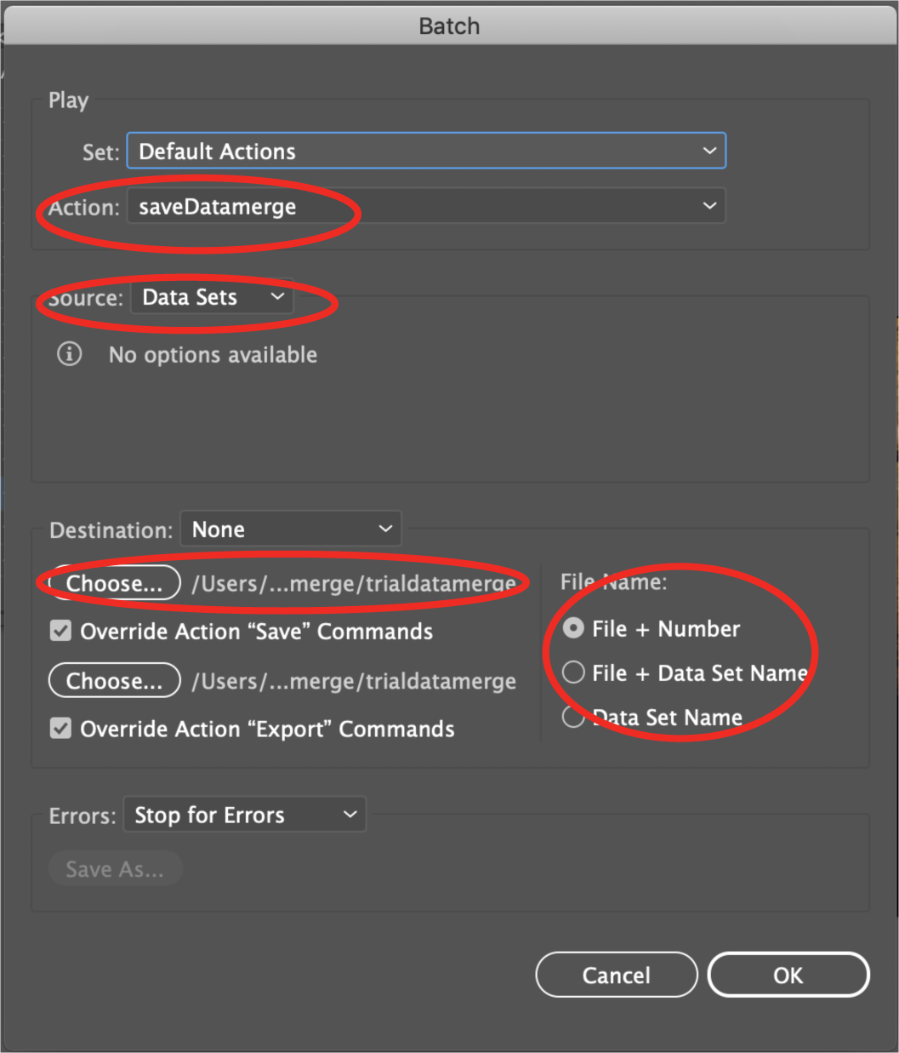
- Select the action that you created in the Action dropdown menu.
- Select Data Sets as your source.
- Choose your new folder in the destination option
- Choose any of the three options on the right for your filename. This will give each document a unique name. If you don’t choose one of these options, then you will end up with just one file, as it will overwrite the file with the same filename each time it processes the data set.
- Press OK

Go to your folder to check that you have the correct number of files. If you had 20 records in your spreadsheet, you should now have 20 different PDF files, each with unique data in it for your outcome.

https://helpx.adobe.com/nz/illustrator/using/data-driven-graphics-templates-variables.html

