The Design Process

Student Workbook

Supports learning and assessment for AS 91891 (3Cr)

Use this workbook together with
Project Log - Design Sprint

DESIGN SPRINT 3
What is a Design Sprint? 3
PRE-SPRINT 4
Investigate Relevant Conventions 4
Aim 4
1 - Basic web conventions 4
2 - Visual Hierarchy 5
3 - Design Style 5
Phase 1 - Understand 6
Aim 6
Part 1 - Unpack the problem 6
Mindmap 6
Braindump 6
Brainwrite 6
Provocation 6
Space Saturate and Group 6
Value Proposition Canvas 6
Part 2 - Outline your Problem Statement 7
Phase 2 - Ideate 8
Aim 8
1 - Identify the conventions you will apply (20 min) 8
2 - Doodle Ideas (20 min) 8
3 - Crazy 8s (8 min) 8
4 - Solution Sketches (30+ min) 8
Phase 3 - Decide 9
Aim 9
1 - Relevant Implications 9
2 - Make a decision 10
3 - Explain and justify your decision 10
Phase 4 - Prototype 11
Aim 11
Generate a prototype 11
Phase 5 - Test and Refine 12
Aim 12
1 - Get feedback 12
2 - Research 12
3 - Refine 12
4 - Explain changes 12
POST-SPRINT 13
Design Sprint Review 13
Aim 13
Interview 13

DESIGN SPRINT

What is a Design Sprint?

A design sprint is a process used by many businesses as the first iteration in developing a new web outcome.
In a design sprint a team will identify the issue and end-user and design the first version of the product.

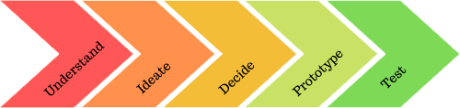

A design sprint is followed by many development sprints where new issues might be identified and the outcome re-designed or taken in new directions.

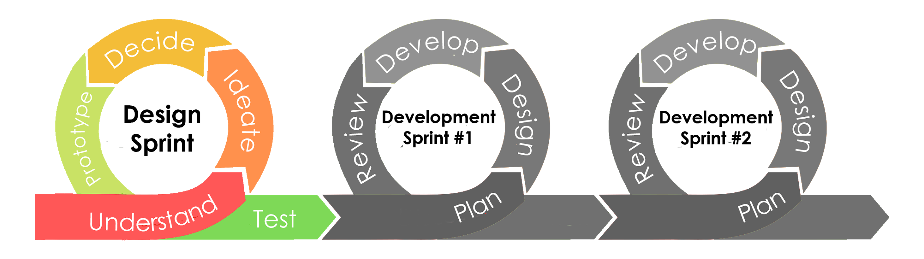

There are five phases of a design sprint: Understand, Ideate, Decide, Prototype and Test.
Each phase of the sprint should take roughly 2 to 3 hours of class time.
This means that the whole Design Sprint should take around 12 hours of class time, plus up to 2 hours for the pre-sprint phase.

A project log has been provided for you to record evidence of your design sprint. You may wish to record your evidence in other ways (such as using a project management tool, scrum board or kanban board).

PRE-SPRINT

Investigate Relevant Conventions

Aim
In this section you need to show evidence that you have
- Investigated relevant conventions

Before you begin the design process, you will need to investigate conventions that you could apply in your digital media outcome.

Conventions are ways in which things are usually done or agreed ways of doing things.

You should be familiar with each of these:
Design conventions - the accepted ways to design things - e.g. wireframes, circuit diagrams, flow diagrams
Web conventions - the ways in which web applications are laid out, structured and operate
File conventions - the ways we name files and folders for web outcomes
Coding conventions - agreed rules on how HTML and CSS code should be laid out, commented and written

For each of the sections below, in your project log, record
- Links to webpages
- Screenshots of examples
- Notes or annotations

1 - Basic web conventions
Look at 3 different existing websites that are related to the purpose of your design

These web pages might help you to come up with some ideas:
https://www.orbitmedia.com/blog/web-design-standards/
https://web3canvas.com/web-design-conventions-never-break/

2 - Visual Hierarchy
Websites (and other digital media outcomes) use a visual hierarchy to make them easier to understand to help users.

Use a search engine to search for visual hierarchy web design.

3 - Design Style
Websites (and other digital media outcomes) are often created to follow a design style or visual language: a pre-made set of rules, principles or design ideas that help guide the designer.

Some examples include:
- Material design
- Flat design
- Skeuomorphic design

These websites might help you with your research
https://material.io/design/environment/surfaces.html#properties Material design
https://www.creativebloq.com/graphic-design/what-flat-design-3132112 Flat Design
https://www.invisionapp.com/inside-design/your-guide-to-using-flat-design/ Flat Design

Use a search engine to investigate one or more of these design styles.

Phase 1 - Understand

1  Understand | 2  Ideate | 3  Decide | 4  Prototype | 5  Test

Aim
The aim of Phase 1 is to understand both the problem/issue/opportunity that you are trying to address and your end users. It is important to empathise with your end user and try to see things from their perspective. This phase is sometimes called the UNPACK or EMPATHISE phase.

In this section you need to show evidence that you have
- Described the purpose of the outcome
- Described the requirements of the end user

Part 1 - Unpack the problem
In your design team explore the problem
Choose a suitable strategy to explore the problem - you could try one of these

Mindmap
Start with your problem statement in the middle of the page, then add ideas that connect to it.

Braindump
Individually write down your ideas about the problem on stick notes, then get together as a group and look at them all.

Brainwrite
Individually write down your ideas about the problem on a piece of paper. After 2 minutes, pass your paper to the next person. Add ideas to their paper. Repeat until everyone has written on every piece of paper.

Provocation
Watch a video or read a story that gives you a new perspective on the issue, then discuss it.

Space Saturate and Group
In your group, collect together all your observations, thoughts, experiences, questions, insights and stories. Write each on a sticky note and stick it to the whiteboard, or use a virtual sticky notes program. Then try grouping related ideas together or drawing links between them.

Value Proposition Canvas
Use the template provided to create a value proposition canvas (you could use a printed copy, edit the copy provided in Google Drawing, or use other software to create your own canvas)
The value proposition canvas will help you to identify the end-user considerations relevant to your problem and outcome.

Make clear who your end users are
- Describe the Gains your users want - what fulfils their needs, makes them happy, ticks their boxes?
- Describe the Pains your users want to avoid - what frustrates them, makes them angry or causes them anxiety?
- Describe the Tasks your user wants to do - what end results might they want from your outcome

Then examine how your digital outcome could help them.
- Describe the gain creators you could offer - features or attributes you could have that would bring your users the gains you have identified
- Describe the pain relievers you could offer - features or attributes you could have that would reduce or remove the pains you have identified
- Describe the products and services you could include - what pages, apps, forms or other services your outcome could that would allow the user to accomplish some of their goals you identified as Tasks.

Part 2 - Outline your Problem Statement
Create an actionable problem statement in this format

User . . . (describe who the user is) needs . . . (what they need to do) because . . . (compelling insight)

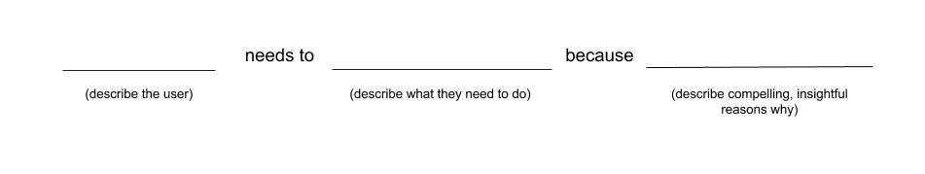
This is called a Point of View (POV) statement

Make sure that in this task you have clearly described
- Who your end users are and what their requirements are
- What the purpose of your outcome is

Phase 2 - Ideate

1  Understand | 2  Ideate | 3  Decide | 4  Prototype | 5  Test

Aim
The aim of this task is to generate a wide variety of design ideas. You will need to know about the conventions that you could apply in your digital media outcome.
Conventions are ways in which things are usually done or agreed ways of doing things

Ideation is a rapid-fire, quick-and-dirty process. It should be done quickly, so time limits have been suggested.

In this section you need to show evidence that you have
- Investigated and applied relevant conventions
- Generated and modelled a range of design ideas

1 - Identify the conventions you will apply (20 min)
As an individual, identify 3 conventions that you will try to apply in your designs.
In your project log jot down some ideas you want to try

2 - Doodle Ideas (20 min)
Draw some quick layout ideas. Show them to your teammates. You should come up with at least 3 widely different ideas

3 - Crazy 8s (8 min)
Each individual in the group does this activity by themselves:
Choose your favourite layout from the last task
Sketch 8 quick variations on that design on paper in 8 minutes

4 - Solution Sketches (30+ min)
You are now ready to draw some serious design sketches

Each group member should create TWO or THREE designs
Designs should be simple wireframes
Label the designs to show where you have applied conventions
Try to make the designs as different as possible - use the widest range of design ideas that you can
You could use an online wireframing tool or draw them by hand
See the examples provided as a guide

Phase 3 - Decide

1  Understand | 2  Ideate | 3  Decide | 4  Prototype | 5  Test

Aim
It is now time to decide which design ideas are the most suitable for your digital media outcome
To do this you will need to identify the implications (the possible future effects or results) that are relevant to your design and explain them. Justify your choices in terms of how the outcome addresses relevant implications.

In this section you need to show evidence of
- explaining relevant implications
- selecting a design for the purpose of the outcome and explaining the appropriateness of the design
- explaining how the chosen design uses appropriate conventions (Merit)
- justifying how the chosen design addresses implications, end-user considerations, and uses appropriate conventions (Excellence)

1 - Relevant Implications
Any digital outcome has implications (possible future effects or results) for the makers, for the users, and for the wider world.

Use the relevant implications resource provided

In your project log, for each implication listed, explain:
- How relevant it is (e.g. highly relevant, not very relevant, not all relevant)
- If it is relevant, explain what it means and why it is relevant to your outcome
- Explain how this implication will affect the design of your outcome

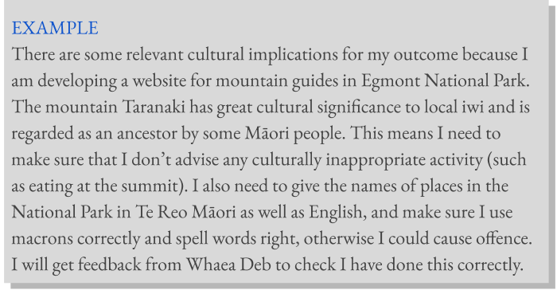

2 - Make a decision
As a team discuss all the designs your team created.
Record the audio of your discussion or have a team member record brief notes.
Attach a link to notes or recording in your project log

Decide which design(s) you will trial in the prototype.
You might choose a combination of features from different design

As a team, create a sketch or description of how your prototype will look.

3 - Explain and justify your decision
Each individual in the team needs to explain and justify the decision that was made.
NOTE: this must be your own, individual work.
Use the notes or recordings from the team decision meeting to help you.

You should make clear how your chosen design was the most appropriate design by saying how it addressed relevant implications and end-user considerations.

Record these explanations in your project log.

Phase 4 - Prototype

1  Understand | 2  Ideate | 3  Decide | 4  Prototype | 5  Test

Aim
It is now time to create a prototype of your design so that you can test it.
This could be
- Made with a prototyping tool (such as Adobe Xd, moqups or JustInMind)
- Drawn using image editing software (such as Adobe Illustrator, Photoshop or Gimp editor)
- Drawn carefully on paper

In this section you need to show evidence that you have
- Applied relevant conventions
- Modelled design ideas

Generate a prototype
Each individual within the team should develop their own prototype.

The prototype should include all website pages in the outcome
The prototype should show
- Size, position and spacing of all elements on the page (accurately)
- Background and text colours
- Placeholder images (background and foreground)
- Borders, shadows, gradients
- How components function (e.g. hover effects, click effects)
- All other important features

Where possible label your design to explain how you used relevant implications and what conventions you are applying.

Phase 5 - Test and Refine

1  Understand | 2  Ideate | 3  Decide | 4  Prototype | 5  Test

Aim
The aim of this phase is to find out how well the outcome addresses relevant implications and end-user considerations, and to improve or refine the outcome

In this section you need to show evidence that you
- used feedback gained from modelling to improve the design (Merit)
- developed an informed design (Merit)
- developed a refined design (Excellence)

1 - Get feedback
Seek feedback from your teacher, assessor, friends or potential end users.
Record your feedback in the feedback table in the project log.

When asking for feedback:
- Ask about how well your outcome meets a specific end-user requirement or implication
- Ask how your outcome could be improved

2 - Research
Find two or more examples of digital outcomes similar to yours that you have not looked at before. Add links or screenshots to the research table in the project log. Make a note of how this informs your design.

3 - Refine
Make changes to your prototype to improve it, based on the feedback you received.
In your project log, record your reasons for making the changes.
Make sure you show evidence of how you improved your design in response to feedback.

4 - Explain changes
Explain how any changes help to address relevant implications or end-user considerations, or use appropriate conventions.

POST-SPRINT

Design Sprint Review

Aim
This is your last opportunity to show evidence of
- using feedback to improve the design
- explaining relevant implications
- explaining how the chosen design uses appropriate conventions
- justifying how the chosen design addresses implications, end-user considerations, and uses appropriate conventions

Interview
Your assessor (or another student) will now interview you for around 5 minutes.
(This could be done in writing or using speech-to-text if a spoken interview is not possible for you)

You will be asked to
- Describe how you used feedback to improve your design
- Explain the most relevant implications for your design
- Explain how you addressed them
- Justify (give arguments and evidence) how you addressed them
- Explain why you chose the most relevant conventions
- Justify your choice of relevant conventions

You should have all of your design work in front of you during the interview so you can see what you did.

Record this in an audio or video file and make sure this is submitted with your design work.

