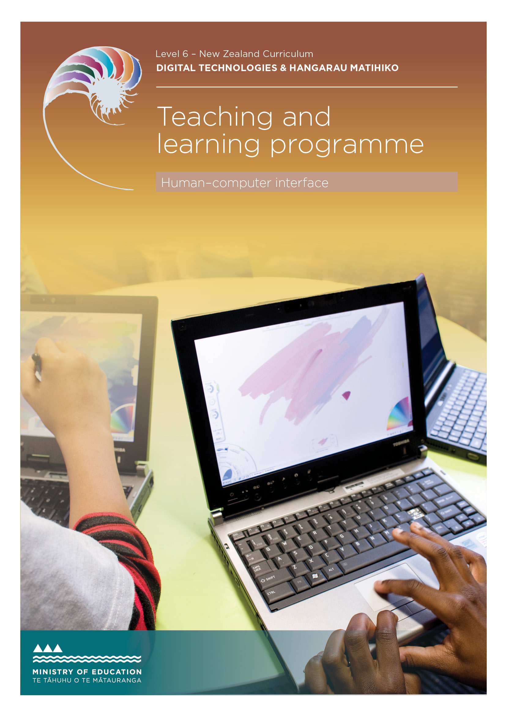

Developed by Caitlin Foran, Open Polytechnic, 2018

External links to websites
The Ministry of Education does not accept any liability for the accuracy of information on external websites, nor for the accuracy or content of any third-party website accessed via a hyperlink from this resource. Links to other websites should not be taken as endorsement of those sites or of products offered on those sites. Some websites have dynamic content, and we cannot accept liability for the content that is displayed.
Published 2018 by the Ministry of Education PO Box 1666, Wellington 6011, New Zealand
www.education.govt.nz All rights reserved Copyright © Crown 2018

Summary of the teaching and learning programme
This programme is designed as interactive online learning modules to support students to complete a report that evaluates a human–computer interface in terms of usability heuristics. To access this programme and materials, you will need to send an email to Malcolm Hewlett Malcolm.hewlett@openpolytechnic.ac.nz and the Open Polytechnic will help you get set up. Classroom activities that could be used to supplement the modules are supplied as part of this programme.

By the end of this teaching and learning programme, students will be able to:
- describe the role of a chosen user interface (achievement)
- identify examples from a given user interface that illustrates usability heuristics
- evaluate a given human–computer interface in terms of usability heuristics
- suggest improvements to a given human– computer interface by comparing and contrasting related interfaces.

Duration
This programme should take approximately
6-8 weeks. This course is the equivalent of 30 hours of teaching, learning and assessment.

Key teaching and learning concepts – the big ideas
There are many ways in which humans and computers can interact. The nature and success of these interactions depends on both the needs and expectations of the human and the usability and features of the computer. We can use the usability heuristics to design and evaluate human–computer interactions.

Alignment to NZC and/or
Te Marautanga – (DTHM progress outcomes and progressions)
Designing and Developing Digital Outcomes
Students understand that digital applications and systems are created for humans
by humans. They develop increasingly sophisticated understandings and skills related to designing and producing quality, fit-for- purpose, digital outcomes.
Links to other learning areas
Other areas of design in terms of considering
your audience and English and/or literacy in terms of completing a report.

Teaching and learning pedagogy
This resource can be used as either a blended or ‘flipped’ model, with students completing activities and watching videos in the online modules in class or at home. Teachers can also use forums, polls, peer and teacher evaluation to engage with students

Prior knowledge and place in learning journey
This resource supports students to evaluate the usability of their own designs, so it makes a great prerequisite for any tasks that require them to design interfaces.

Resources required
Internet access and online resource. To access the online resource please send an email to Malcolm Hewlett Malcolm.hewlett@ openpolytechnic.ac.nz and the Open Polytechnic will help you get set up.
This programme is found on TKI accessible from here.

How you might adapt this in your classroom
Suggested activities to extend learners are described in the outline below. Teachers can also adapt the resource by adding contexts relevant to their particular students or using LTI to link in with existing applications.

Assessment
Students create a report that evaluates a human–computer interface in terms of usability heuristics.
AS 91886: Demonstrate understanding of human–computer interaction

TERM OUTLINE

Teaching and learning programme

What is being covered | Duration | Specific learning outcomes  Students will be able to: | Learning activities | Resources
Introduction | ½ lesson | - identify examples of user interfaces  - define HCI  - describe the purpose of a simple interaction. | Identify examples of the user interface on their computer: mouse, keyboard, screen. Then describe the purpose or role of that interface.  Optional extra  Show students what was used before interfaces using this timeline of computer history.
The human element of HCI | ½ lesson | - identify which senses are used in a given HCI. | Based on the examples of user interfaces provided, match the sense with an interface (keyboard, mouse, monitor, printer, microphone, VR headset – feedback needs to explain that these are examples of HCI).  Describe an example of one or two applications they use that focus on a chosen sense.  Class discussion or forum  Watch TRANSFORM – Amazing Technology Invented by MIT After watching, discuss:  - Which did you think was the coolest example?  - What senses are we using? Potential applications?  Follow up with Shape-shifting tech will change work as we know it . Potential discussion prompts depending on the interests and levels of your students:  - Sean describes interacting with our forms as a ‘richer’ way of interacting – what do you think?  - At the end we saw a game played on a mobile using physical buttons. We had devices like this many years ago. Is this nostalgia? Progress? Regression?  - Why do you think designers would want to incorporate physical buttons again?  - At what point do computer interactions limit our non-computer interactions? Is this making a table more useful or unnecessarily complex?

What is being covered | Duration | Specific learning outcomes  Students will be able to: | Learning activities | Resources
Different users have different needs | 1 lesson | - describe an example where different users would have different needs. | Match a special need with a user interface (Zimmer frame, hearing aid, Braille book).  Describe a time when they (or someone they’ve known) has had to use a tool for a disability. They then explain the purpose of that tool and describe the features that enable this purpose.  Optional extra  Have students create user personas, one for themselves and one for another user type, eg, their sibling, parent, teacher. | Xtensio takes students through How to create a persona and has a tool they can use.  Example student personas from the Open Polytechnic
Understanding the computer element | ½ lesson | - describe the input, output and processors for a chosen device. | Class discussion or forum  In what ways are humans different to computers? In what ways are they the same?  Match the tool or device with its intended use or purpose (MS Word, iWatch, iPhone, digital scales, Facebook).  Iidentify and match the component as an input, output or process (mouse, screen, RAM).  Optional extra: The difference between humans and machines. This idea has been prevalent in popular culture, and you could talk to students about Humans, Ex machina or I, Robot then segue into the Turing test.  Ask students: Have they used chatbots before? This could lead into a discussion about how interaction design could simulate human conversation or if it should? | The Turing test: Can a computer pass for a human? explains the Turing test and describes  a few of the chatbots that have passed this test.  Woebot is an example of a chatbot that students can sign up to chat with through Messenger to explore the nature of the interactions.

What is being covered | Duration | Specific learning outcomes  Students will be able to: | Learning activities | Resources
Understanding interactions | 1 lesson | - use the process of a cognitive walkthrough to record interactions with a device. | Class activity  Ask a volunteer to do a ‘think-aloud walkthrough’ of performing a simple task, such as eating an orange, making a paper plane, tying a shoelace or setting an alarm on their phone. (This would be best if you can show their display on the projector.)  Describe or draw the steps they (as a user) go through to perform a simple task, for instance, pair with a new bluetooth device, transfer money to someone, purchase something from an online store.  Record each step and describe the role it played in the process to complete the task. | How to do a cognitive walkthrough
What is usability? | ½ lesson | - align features of a tool with its intended use. | Describe an instance where they’ve found something hard to interact with for some reason.  Find five examples of poor user design, then explain why they are bad examples.  Describe an application or site they use that they find easy and enjoyable to use.  What is it about this application or site that makes it so great to use?  Describe the role of this application or site – what is its purpose?

What is being covered | Duration | Specific learning outcomes  Students will be able to: | Learning activities | Resources
Trade-offs | ½ lesson | - identify instances where designers sacrificed in one area to gain in another. | Discuss how a HCI may be good in one way but not others – trade-offs, for instance, put all buttons on the screen, but then lose screen real estate.  Class discussion or forum  Many of us have different devices these days – possibly a phone, tablet or laptop.  Which activities do you use for which? For example, writing an essay, gaming or shopping online?  At which point would you switch from using one to the other?  What is it about the design or nature of interactions that makes you switch?
Module two: Usability
Introduction to usability and heuristics | ½ lesson | - identify instances where designers sacrificed in one area to gain in another. | Think back to comments about an application or site you love using. Write down (on small slips of paper) five aspects that make this great to use.  Class activity  In groups or as a class, get students to see if there are similarities in what they’ve written. Can they categorise or group the reasons?
Visibility | ½ lesson | - give an example of the visibility heuristic  - explain how a given interface performs in relation to visibility. | Explore examples of the heuristic: time till arrival for Google Maps, fuel gauge, progress bar.  Rank these progress visuals in order of effectiveness: spinning wheels, endless clock, or progress bar or progress bar with %.

What is being covered | Duration | Specific learning outcomes  Students will be able to: | Learning activities | Resources
Difference between system and real world | ½ lesson | - give an example of the difference between system and real-world heuristic  - explain how a given interface performs in relation to difference between system and real world. | Explore examples of the heuristic: US calendar entries, floppy disk for Save and inverted traffic.  Identify the most obvious colour for these signs: hot/ cold, stop/go, warning, exit.
Consistency in standards | ½ lesson | - give an example of the consistency in standards heuristic  - explain how a given interface performs in relation to consistency in standards. | Explore examples of the heuristic: play, stop, pause button, back, hyperlinks change colour.  Match the keystrokes to the emoji.
Recognition | ½ lesson | - give an example of the recognition heuristic  - explain how a given interface performs in relation to recognition. | Explore examples of the heuristic: Word icons, predictive text  Suggest some improved alternatives to historic icons: save, paper shredder instead of rubbish bin.
Error prevention | ½ lesson | - give an example of the error prevention heuristic  - explain how a given interface performs in relation to error prevention. | Explore examples of the heuristic: account remains active for X days, “Are you sure?”  Do three ‘close’ exercises to make a meaningful error message.
Error recovery | ½ lesson | - give an example of the error recovery heuristic.  - explain how a given interface performs in relation to error recovery. | Explore examples of the heuristic: “Did you mean?”, recycle bin.  Based on five examples of good and bad error messages, rank them in order.  Suggest an even better error message for a given example.

What is being covered | Duration | Specific learning outcomes  Students will be able to: | Learning activities | Resources
User control and freedom | ½ lesson | - give an example of the user control and freedom heuristic.  - Explain how a given interface performs in relation to user control and freedom. | Explore examples of the heuristic: undo/redo and the AdBlocker ability to block on certain pages or certain ads.  Identify examples of interactions with a computer that may require confirmation: exit without saving, restart, bank transfer, etc.; copy a file vs delete  a file.
Flexibility | ½ lesson | - give an example of the flexibility heuristic  - explain how a given interface performs in relation to flexibility. | Explore examples of the heuristic: quick keys, font sizing, zooming on phone, gesture typing, fingerprint swipe.  Identify common shortcut keys: For example; CtrL+C and describe their role.
Aesthetics | ½ lesson | - give an example of the aesthetics heuristic  - explain how a given interface performs in relation to aesthetics. | Explore examples of the heuristic: Web page, white space, font size, colours, giving users the opportunity to customise their page.  On a website builder, move buttons, change background colours, text colours, etc. with the goal of either making the most useless or best interface.  Suggest some alternative colour schemes for simple layouts and justify your decisions.
Help | ½ lesson | - give an example of the help heuristic  - explain how a given interface performs in relation to help. | Explore examples of the heuristic: Age of Empires, kids’ games indicate which button to press  Find two example sites or applications that provide help within the site. Which is better? Why? How could the poorer example be improved?

What is being covered | Duration | Specific learning outcomes  Students will be able to: | Learning activities | Resources
Module three: Reporting
Beginning writing | 1 lesson | - state the purpose of an interface  - write an evaluative sentence about an interface based on the usability heuristics  - suggest an improvement to an interface based on the usability heuristics. | Class activity  In pairs or groups, students can use the evaluation sentence starters to interview one another on their opinion of an interface.  With an example interface (use older interfaces as examples so that students can more easily think of improvements):  - state the purpose of the interface  - write an evaluative sentence about the interface based on the usability heuristics.  - use one of the sentence starters to suggest an improvement based on the usability heuristics. | Evaluation sentence starters
Evaluation and critique | 1 lesson | - critique an interface with reference to the relevant heuristics. | Scaffold students through a critique of an interface with reference to the relevant heuristics.
Choosing a device or GUI | ½ lesson | - identify a suitable interface to evaluate. | Choose a device for the report, after identifying which devices are suitable (or not).
Gathering evidence | ⅓ lesson | - undertake a survey of users to support an evaluation of a human– computer interface. | Remind students of the cognitive walkthrough.  Peer review and opinions: for a chosen user interface, ask peers what their opinion is based on the usability heuristics. (You may prompt them with some sentences.)  Use this feedback in their report if it relates to the device they are reporting on.
Images | ⅓ lesson | - select images to support an evaluation of a human–computer interface. | Identify from a list the images that support the statement and those that do not provide additional evidence.

What is being covered | Duration | Specific learning outcomes  Students will be able to: | Learning activities | Resources
Referencing | ⅓ lesson | - provide references to support an evaluation of a human–computer interface. | Find links to websites that provide additional information that reinforces what has been learned so far.
Exemplary work | ½ lesson | - analyse reports to identify if they have met the standard. | Given a list of exemplar sentences and paragraphs, rank them as NA, A , M and E.
Writing your report | 3 lessons | - create a report that evaluates a human–computer interface in terms of usability heuristics. | Write a report from the supplied template and guidelines.

ASSESSMENT TASK
91886
Demonstrate understanding of human–computer interaction 3
Achievement standard: Standard title:
Total credits:

OVERVIEW
This assessment activity requires you to identify examples from a given user interface, describe the role of the interface, evaluate the interface, and suggest improvements in terms of usability
HOW WILL YOU BE ASSESSED?
Your response will be assessed on how comprehensively you demonstrate understanding of human–computer interaction
TASK
Respond to the interface questions below. Your responses should seek to demonstrate comprehensive understanding of human–computer interaction.
Domino’s opened its first New Zealand store in 2003. It has since expanded across the country. Domino’s has invested in such technology as GPS driver tracking and improved online ordering systems. Many of the changes made to online ordering systems have been made to improve the human– computer interface (HCI).
Below is an image of the current Domino’s homepage. (In each year, a different interface will be selected.)

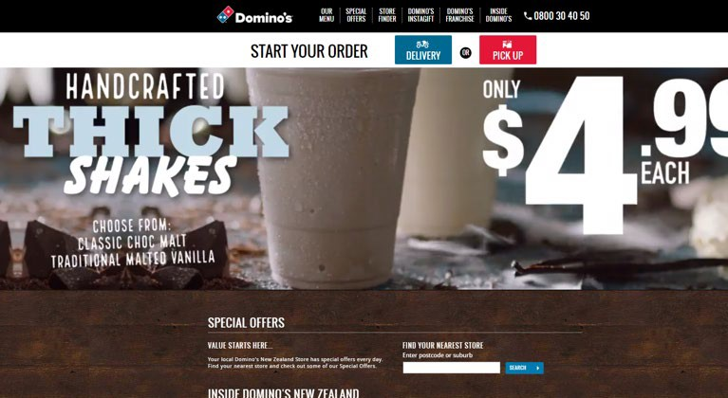

ASSESSMENT TASK
91886
Demonstrate understanding of human–computer interaction 3
Achievement standard: Standard title:
Total credits:

TASK (CONTINUED)
You are a computer scientist. Your task is to write a report that evaluates this interface. Use the tasks below to construct your report.
- Describe the purpose of the Domino’s website.
- For EACH of the usability heuristics:
  - Identify whether the Domino’s site meets, partly meets, or does not meet that heuristic.
  - Give an example of a feature of the Domino’s site as evidence of meeting (or violating) that heuristic.
  - Explain how these features of the interface affect the interaction.
- Suggest at least two improvements to the Domino’s site by comparing and contrasting it to a similar site AND explain how these changes would improve the interaction.
HAND IN
A report that answers the numbered tasks above. Determine the length of this report with your teacher. The report should focus on quality not length.

TEACHER GUIDELINES

The following guidelines are supplied to support teachers/kaiako to carry out valid and consistent assessment using this internal assessment resource.
Teachers/kaiako need to be very familiar with the outcome being assessed by the achievement standard/s. The achievement criteria and the explanatory notes contain information, definitions and requirements that are crucial when interpreting the standard and assessing students/ākonga against it.
Please be aware that NZQA have read the assessment task but the task will still need to be checked by the teacher using the assessment to ensure it meets all requirements.
CONTEXT/TE HOROPAKI
This assessment activity requires students to respond digitally to the material presented in the common assessment task to demonstrate their understanding of human–computer interaction. The context of this example is an online interface.
CONDITIONS/NGĀ TIKANGA
Teaching and learning should take place within a collaborative environment consistent with the Nature of Technology strand of the Technology learning area. Students should produce an individual response to the assessment stimulus for the purposes of summative assessment.
Assessment specifications for this achievement standard can be found on the NZQA’s NCEA subject page. Conditions of Assessment related to this achievement standard can be found at http://ncea.tki.org.nz/
Student responses must be submitted following the school’s authenticity verification process. The school’s authenticity process must be informed by authenticity requirements for non-examination external assessment by NZQA.
Student responses must be uploaded digitally on the specified date.

ASSESSMENT SCHEDULE: AS 91886 – DEMONSTRATE UNDERSTANDING OF HUMAN–COMPUTER INTERACTION

EVIDENCE/JUDGMENTS FOR ACHIEVEMENT/PAETAE | EVIDENCE/JUDGMENTS FOR ACHIEVEMENT WITH MERIT/KAIAKA | EVIDENCE/JUDGMENTS FOR ACHIEVEMENT WITH EXCELLENCE/KAIRANGI
Demonstrate understanding of human–computer interaction | Demonstrate in-depth understanding of human– computer interaction. | Demonstrate comprehensive understanding of human–computer interaction.
The student has:  - described the role (purpose) of the interface (Domino’s homepage)  - Identified examples of features from the interface that illustrate usability heuristics  For example (partial evidence)  {The interface} is intended for {target audience} to  {purpose}.  The main ideas of {the interface} are …  To do {action} with {the interface}, you do {these things}. | The student has:  - evaluated the interface in terms of usability heuristics.  For example (partial evidence)  {The interface} does/doesn’t meet {usability heuristic} because …  {Feature of interface} is a good/bad example of the {usability heuristic} because …  It is easy/hard to achieve {action} with {feature/ interface} because of {usability heuristic}. | The student has:  - suggested improvements to the interface by comparing and contrasting related interfaces.  For example (partial evidence)  {The interface} would be improved by {change to feature} because {link to heuristic(s)}.  By comparing this interface to {other similar interface}, you can see {description of where one interface performs better}.  To fix {problem} you could {solution}.  Note: Suggested improvements must link to the heuristic(s) and should use keywords from the definition of that heuristic. Statements may be supported with screenshots.

Final grades will be determined on a holistic examination of the evidence provided against the criteria in the achievement standard.
To access this programme and materials, you will need to send an email to Malcolm Hewlett Malcolm.hewlett@openpolytechnic.ac.nz and the Open Polytechnic will help you get set up. This teaching and learning programme is accessible on TKI.

