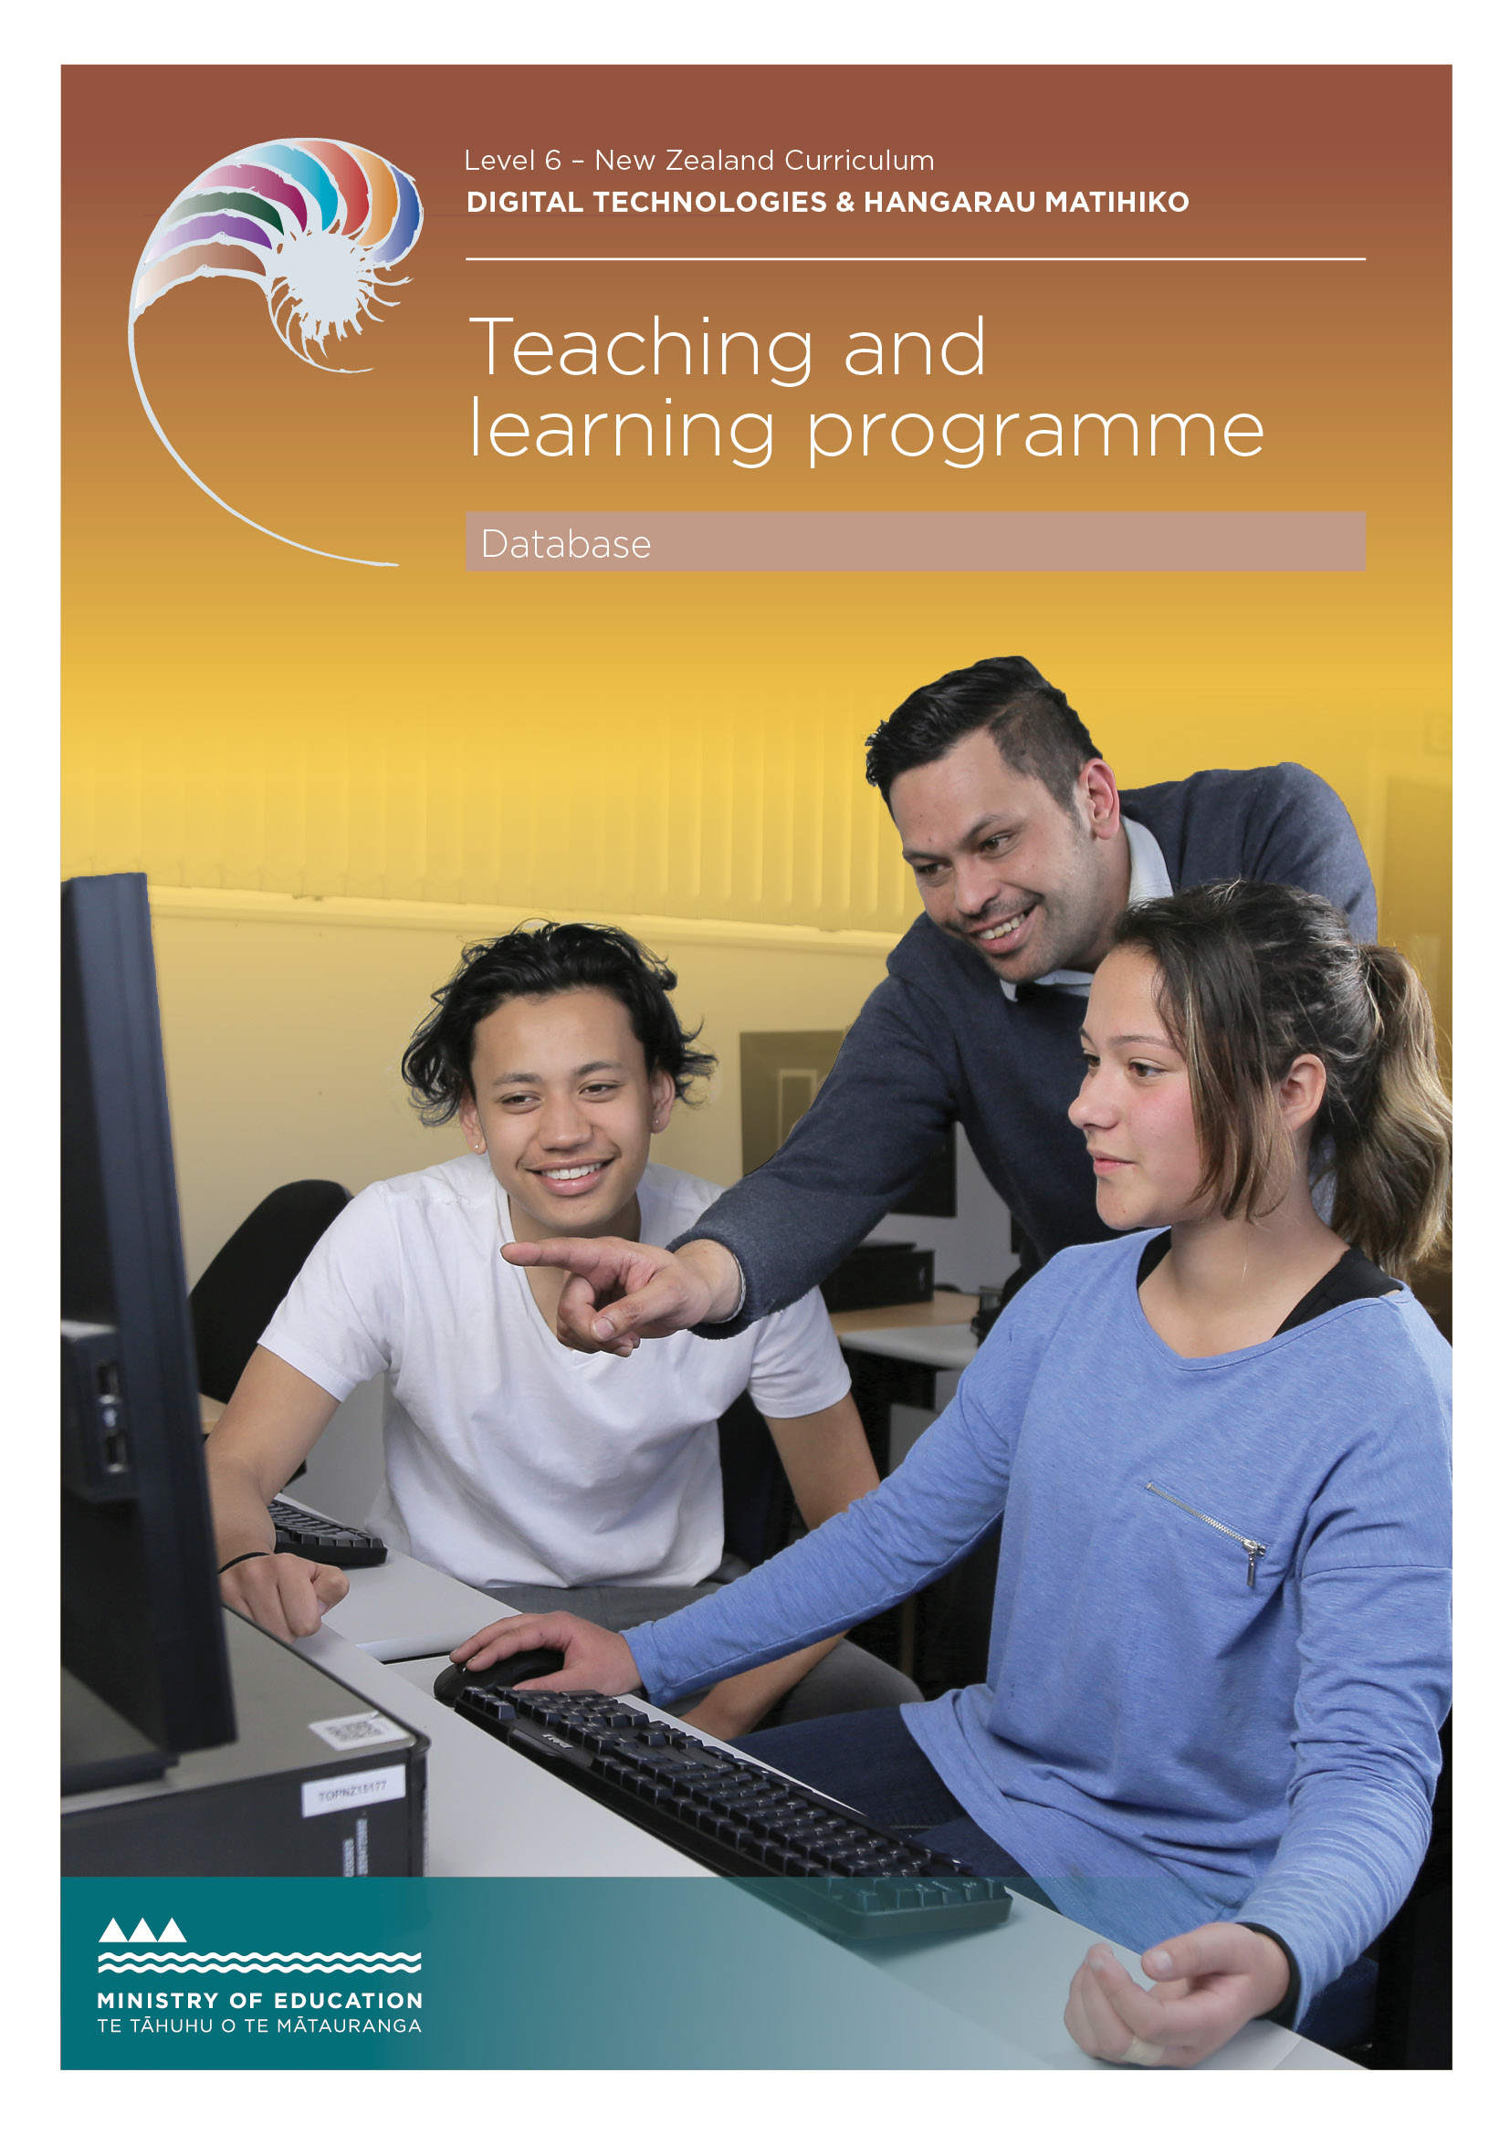

Developed by Jennifer Gottschalk, Whangaparaoa College, 2018
External links to websites
The Ministry of Education does not accept any liability for the accuracy of information on external websites, nor for the accuracy or content of any third-party website accessed via a hyperlink from this resource. Links to other websites should not be taken as endorsement of those sites or of products offered on those sites. Some websites have dynamic content, and we cannot accept liability for the content that is displayed.
Published 2018 by the Ministry of Education PO Box 1666, Wellington 6011, New Zealand
www.education.govt.nz All rights reserved Copyright © Crown 2018

Summary of teaching and learning programme
This programme is based on ‘flipped learning’ pedagogy and uses an eBook tutorial that includes embedded video. Students are provided with detailed instructions and walk-throughs showing how to create a fully functioning, refined database and website using HTML, CSS, SQL and PHP. It is assumed that students have prior learning in web development and are able to create basic HTML and CSS websites.

By the end of this teaching and learning programme, students will be able to:
- create a simple database via PHPMyAdmin’s dashboard
- repurpose a simple website so that it can be used to display information held in the database
- query the database and display the results on a web page.

Duration
Approximately 40 hours of teaching, learning and assessment. Teachers should adjust this programme to suit their students and timetables.

Key teaching and learning concepts – the big ideas
- Websites can be created using HTML and CSS.
- We can populate our website with a database backend.
- Queries can be used to find specific information and this can be displayed via a webpage.
- Both HTML and CSS should be validated to ensure that the final outcome is robust and future proof.
- A well-designed site is easy to use. Usability should be confirmed by doing simple usability testing.

Alignment to NZC and/or
Te Marautanga – (DTHM progress outcomes and progressions)
This material is focused on ‘designing and developing digital outcomes’. Students will:
- design and develop a basic database and website outcome
- ensure that the outcomes are easy to use (preferably by including some usability testing as part of the process)
- be ethical when it comes to designing and creating their outcome. Specifically they will honour copyright and will also respect their users’ privacy.

Links to other learning areas
This programme involves documenting several books that students have read and could be used in conjunction with English achievement standard 90854.

Teaching and learning pedagogy
The programme makes considerable use of ‘flipped’ learning, where the process has
been videoed and students are encouraged to create their own practice database and website by following the video tutorials.
They are also encouraged to go beyond the basics where possible. By using an eBook with video, teachers are free to work with individuals and troubleshoot in a way that would not be possible using more traditional methods. Teachers could encourage students to collaborate and work in small groups during the learning phase for this standard.

Prior knowledge and place in learning journey
It is assumed that students are able to create basic websites using CSS and HTML.
Most should have successfully completed achievement standard 91880 Develop a digital media outcome.

Resources required
- The learning resource – the ePub and support files. Note that this includes ‘teacher only’ answers and a teaching guide.
- An internet connection
- A suitable text editor (Brackets is used for this resource)
- A modern browser (Firefox is ideal, Chrome is OK. Internet Explorer would be a browser of last resort as it does not have a developer console.)
- Access to a PHP and database environment. Using XAMPP (local host) is one option.
Software used:
- XAMPP (phpMyAdmin)
- Brackets
- GIMP (for minor image editing)
- Firefox / Chrome
- Draw.io
- QiuReader (Mozilla) / Readium (Chrome)

How you might adapt this in your classroom
The task or the content of the database can be changed to any situation where you have data that users might want to search or filter. This could include keeping track of a collection of items, fact sheets on animals or plants (where each fact sheet is one entry in the table) or even competition results for a sports team.
Differentiation occurs through the sophistication of the student outcomes. Students working at a basic level might only have one way to search for a book’s rating (eg, only has ‘equal to’ rather than the ‘more’ and ‘less’ options). Students working at a high level might investigate how to include images in their database entries (ie, store the link to the image and then ensure that the image is displayed on a hosted site).

Assessment
See the assessment task associated with this programme. The default task asks students to create a database and website reviewing some of their favourite foods and eating establishments.

TERM OUTLINE

TERM 1 | Week 1 | Week 2 | Week 3 | Week 4 | Week 5 | Week 6 | Week 7
Topics covered | Basic databases (91879)
Week plan | Planning and DB set-up | Page set-up | Queries |  | Usability testing | Assessment

Teaching and learning programme

What is being covered | Duration | Specific learning outcomes  Students will be able to: | Learning activities | Checkpoints | Resources
Plan outcome and create database | 5 hours | - create a plan for the database and website  - set up the basic structure of the first page. | - Download required software if using own device.  - Download ePub and support files.  - Set up folder structure.  - Create a wire frame for the site.  - Plan the database. Pay particular attention to the datatypes chosen for each field.  - Recycle your old code to create your website. This could include recolouring the page if desired. | Checkpoint 1: Submit the following:  - Screenshot of your index page with ‘new’ colours. Irrelevant material from the ‘old’ site should be removed.  Teacher note: you could ask students to submit their code instead of a screenshot but screenshots are quick to mark and should give an indication of whether students have done the required work | Software Firefox brackets  XAMPP (for PHP  includes)
 |  |  |  |  | draw.io (wire framing)
 |  |  |  |  | Plugins (Firefox)
 |  |  |  |  | QiuReader
 |  |  |  |  | FireShot

What is being covered | Duration | Specific learning outcomes  Students will be able to: | Learning activities | Checkpoints | Resources
Create database | 3 hours | - create a database  - Demonstrate how testing informs development and that changes happen in an ongoing manner. | - Create your database and import the records provided in the Support Files area. | Checkpoint 2: Submit the following:  - Evidence template that includes wire frame and database planning  - Screenshots showing that database has been created (see below). | ePub and documentation template
Queries (10 hours) | 10 hours | - create a series of queries to display information  in the database on the website  - create a search area to allow users to search through the database | - Create a page that shows users all of the entries in the database.  - Create a query that allows users to search by title (or part of a title).  - Create a query that allows users to search by author name (or part of an author’s name).  - Create a query that allows users to search by genre (using a drop- down).  - Create a query that allows users to search by rating. | Checkpoint 3a: Submit the following:  - Screenshots showing that your database and website are linked (ie, a screenshot of the page that shows all entries in the database).  Checkpoint 3b: Submit the following:  - Your evidence template showing that you have successfully set up and tested your queries.  Teacher note: Generally I will take a student’s word that their HTML validates and will spot- check pages. If the contact page validates, usually the rest of the  pages are fine too. If you do want to spot-check student code, ask them to submit their code as well as the associated screenshots. (It will take longer to mark.)

What is being covered | Duration | Specific learning outcomes  Students will be able to: | Learning activities | Checkpoints | Resources
Usability | As needed | - confirm that the database is easy to use by asking a volunteer to test it. | - Ask a volunteer to test the database and website in terms of usability.  - Make notes on anything that requires changing.  - Take ‘before’ screenshots.  - Fix the issues.  - Take ‘after’ screenshots showing how the outcome has been refined.  - Write one or two line notes or justifications where necessary explaining how you refined the site. | Checkpoint 4: Practice database and website  Submit your practice outcome and documentation, which should  include the results of your usability testing. | Usability ‘script’
Assessment | Two weeks | Students should have two weeks of class time to create their database and website and associated documentation.

ASSESSMENT TASK

Achievement standard: 91879
Standard title: Develop a digital outcome to manage data
Total credits: 4 credits

OVERVIEW
This assessment activity requires you to create an outcome to manage data. The data will be presented by linking the database to a website from a previous assessment or practice task.
HOW WILL YOU BE ASSESSED?
You are going to be assessed on how successfully you structure, organise, query and present data from your database.
TASK
Structure, organise, query and present data for the following scenario:
Scenario:
You have a passion for food and have decided to extend the website you made earlier so that you can allow users to search through the foods you have reviewed and easily access the information about the dish (eg, rating, vegetarian, review). The plan is to create a database to hold the information as this is quick and easy to update and search.
You need to:
- Structure a simple database that includes key information for each dish being reviewed. Think about how you will set up your database so that users can search for dishes (eg, they might want to search by rating, location etc.)
- Apply appropriate data integrity procedures to ensure your data is accurate
- Create or extend a website to display the information. You may have an already developed website that you could use for this.
- Set up a range of queries to allow users to search for reviews (eg, allow users to search by rating, location, etc.)
- Test that the output from the website / database is easy to read and that the overall outcome is easy to use.

ASSESSMENT TASK

Achievement standard: 91879
Standard title: Develop a digital outcome to manage data
Total credits: 4 credits

TASK (continued)
You also need to provide documentation showing:
- Database structuring. This would include a database structure diagram showing the fields, data types and sizes that will be used.
- Outcome refinement. During the development of the database (and website), you will iteratively improve the outcome. You also need to apply data integrity testing procedures to improve the quality and functionality of the outcome. When this happens, please include ‘before’ and ‘after’ screenshots explaining what you changed, and why, and how this improved the quality and functionality of the outcome.
- Testing. Screenshots or a screencast showing that the database and website have been tested and work as expected. If you have made changes to your outcome based on usability testing, provide a brief statement explaining what has been changed and why.
Testing can be done by making a brief screencast showing the outcome being comprehensively tested. If desired, you can take screenshots of your screencast and annotate them. This is often easier than trying to screenshot whilst testing where it is easy to ‘forget’ to screenshot a key part of the test. If you prefer, you are welcome to talk us through your testing and simply submit a brief screencast (screencasts should be 3 minutes or less in length).
- That implications have been described, considered and addressed. For example, a discussion on how your outcome:
  - is suitable for the intended audience
  - is socially and culturally acceptable
  - honours legal, ethical and intellectual property obligations
  - is accessible, usable and functional.
HAND IN
- Your website files
- The SQL for your database
- A document in which you show how you have tested and refined your outcome. You are welcome to submit additional video files showing the testing of your database and website.

APPENDIX A – SAMPLE DATA

Smoked salmon omelette  (Breakfast, home)  This is a Sunday morning event and is one of my favourite foods. The omelette is made with one egg and filled with a generous serve of smoked  salmon and cream cheese. In summer, the addition of fresh chives makes this meal extra- special. It is normally served with two slices of wholemeal toast and butter. This gets a rating of 5/5. | Filo chicken ‘pie’ (Dinner, home)  This winter treat includes roast chicken, mixed stir fry veggies and a delightful sauce. It is topped with  crumpled up filo sheets and a generous sprinkling of sesame seeds. This ‘pie’ is  really tasty and is best served piping hot. It is one of my mother’s signature dishes, which means that if I give it anything less than a five-star rating, things will not end well. This gets a rating of  5/5. | Sushi (Lunch, Sushi Ya)  This is probably the best sushi shop in Auckland. The prices are reasonable, the pieces are generously  sized and the ratio of rice to filling is perfect (ie, loads of filling with a relatively small amount of rice). They have a surprisingly large range for the size of the shop and  their salmon and tuna sushi is particularly good. This gets a rating of 5/5. | Affogato (Dessert, Tascas)  This dish is vegetarian.  For the uninitiated, affogato is basically a scoop of vanilla ice cream ‘drowned’ in a shot of hot espresso. This is  combines two of my favourite things, ice cream and coffee. Provided the coffee (and ice cream) are of high quality, this is the ultimate simple dessert. Tascas does this quite well. This gets a rating of 4/5. | Sushi (Lunch, St Pierres)  To be fair I had this a very long time ago but, I still remember it as being too much rice and not nearly enough other fillings – so much so that I won’t go there again. This gets a rating of 2/5.
Tuna salad (Lunch, home)  This one involves a large bowl of lettuce, avocado, salad dressing and smoked tinned tuna. It’s healthy and surprisingly filling, but if I’m honest, it’s not all that inspiring. It tastes OK  provided the lettuce is fresh, but it is nowhere near as nice as other options that are out there. The upside is that it is quick and easy to assemble. This gets a rating of 3/5. | Lamb kebab (Dinner, Ephesus Turkish Kitchen)  This is one of my favourite ‘eating out’ dinners. The combination of flat bread, humous, lettuce, lamb and other random ingredients is really, really, good. The only slight ‘problem’ is that  the portion size is extremely generous, which generally means having no room left for dessert. This gets a rating of 4/5. | Chicken fillet sub (Lunch, Subway)  The good thing about Subway is the choice when it comes to bread, salads and fillings. I’m somewhat ambivalent when it comes to the chicken sub – it’s ‘OK’ but a six inch is not enough, and a twelve inch is way too much. I like that the sandwich has less than six grams of fat, but I just  can’t get all that excited over what is basically a chicken sandwich. This gets a rating of 3/5. | Blind scouse (Lunch, home)  This dish is vegetarian.  This is one of those ‘make it in advance’, freeze it and  then eat it jobs. It is basically a stew made of potato, car- rots, lentils and spices. The good thing about it is that it quick to reheat, healthy and filling. Having said that, it is not something you’d want to eat every day as it can be a bit boring. This gets a rating of 3/5. | French toast (Breakfast, home)  This dish is vegetarian.  The trick to this one is to use home-made raisin bread (instead of shop-bought white or brown bread) and  be generous with the amount of syrup or cinnamon and sugar added on the top.  Provided the egg is properly cooked, this is the ultimate in decadent breakfasts. It is a once-a- year treat that is totally worth every calorie. This gets a rating of 5/5.

TEACHER /KAIAKO GUIDELINES

The following guidelines are supplied to support teachers/kaiako to carry out valid and consistent assessment using this internal assessment resource.
Teachers/kaiako need to be very familiar with the outcome being assessed by the achievement standard. The achievement criteria and the explanatory notes contain information, definitions, and requirements that are crucial when interpreting the standard and assessing students/ākonga against it.
Please be aware that NZQA have read the assessment task but the task will still need to be checked by the teacher using the assessment to ensure it meets all requirements.
CONTEXT/TE HOROPAKI
The assessment activity requires students to create a website that is populated by content from a simple database using appropriate techniques. Please see the student task for more details.
Teachers are encouraged to edit this default task to make it suitable for their community.
NOTE: This assessment assumes that students have worked through the resource that shows how to create a simple linked database and website. If your students have not done this, then using this assessment is not appropriate. This assessment could be modified to assess BOTH web design and database work (although that could be risky for students who ‘get’ websites but not databases).
Please allow students to either complete the default task (see student task) or ‘pitch’ an alternate idea. Provided their idea allows them to use suitable techniques to create a website, they should be encouraged to develop their custom solution.
CONDITIONS/NGĀ TIKANGA
It is recommended that students should have at least two identified checkpoints with their teacher as they work through this assessment activity, to ensure that they have an opportunity to ask questions and gather feedback.
The format of the final outcome is a website.
Conditions of Assessment related to this achievement standard can be found at http://ncea.tki.org.nz/
RESOURCE REQUIREMENTS/NGĀ RAUEMI
Students will need access to the web, a text editor (such as Brackets), image manipulation software such as GIMP or Photoshop and a suitable hosting (eg, XAMPP localhost)

ASSESSMENT SCHEDULE/MAHERE AROMATAWAI

EVIDENCE/JUDGMENTS FOR ACHIEVEMENT/PAETAE | EVIDENCE/JUDGMENTS FOR ACHIEVEMENT WITH MERIT/KAIAKA | EVIDENCE/JUDGMENTS FOR ACHIEVEMENT WITH EXCELLENCE/KAIRANGI
Develop a digital media outcome | Develop an informed digital media outcome. | Develop a refined digital media outcome.
The student has:  - used appropriate tools and techniques to structure, organise, query and present data for a purpose and end-user  For example (partial evidence – outcome does not need to include everything in the list below):  The purpose of the database is to allow end-users to search through and view food reviews.  The student has structured and created a database linked to a website. The site has been styled using CSS and the site and database have been connected using PHP.  The database table includes fields for the ID (primary key), name of the item, the location of the eatery, the category (e.g breakfast, lunch, dinner etc), the review and the rating.  Most of the fields will have a data type of text (i.e varchar) but the review field should be an integer.  The database can be queried via the website where users can search for reviews based on the name of the dish, the category (breakfast / lunch / dinner), the rating and whether the dish is vegetarian. | The student has:  - used information from testing procedures to improve the quality and functionality of the outcome  For example (partial evidence – documentation could include alternate evidence):  Student evidence includes ‘before’ and ‘after’ screenshots showing how some parts of the site and database have been fixed or edited to improve the outcome. | The student has:  - iteratively improved the outcome throughout the development and testing process  For example (partial evidence – documentation could include alternate evidence):  Student evidence includes a number of ‘before’ and ‘after’ screenshots showing how the outcome has been iteratively developed and improved.  The student has brief justifications or explanations between iterations explaining key decisions that have been made.

ASSESSMENT SCHEDULE/MAHERE AROMATAWAI

The student has:  - applied appropriate data integrity and testing procedures  For example (partial evidence):  The database allows users to see all entries, which are listed either by rating or alphabetically (or any way that is logical and sensible).  The database and website has been tested and it works as expected. For example, if a user searches for ‘breakfast’ reviews, the entries for French Toast and Smoked salmon omelette should be displayed.  If a search does not yield any results, users see a ‘no results’ message. (This might have minimal formatting.)  The site has been tested showing, what happens when a result is returned and when there are no results to display for a given query.  The student has:  - described relevant implications.  For example (partial evidence):  The student has described what copyright is (related to the outcome.)  The student has described appropriate tone and language that might be expected in an outcome of this nature. For example, polite review without causing offence.  The student has described good usability related to the outcome. | The student has:  - structured, organised and queried the data logically  For example (partial evidence):  The order of queries in the search area is logical and follows the order of a typical review (eg: Name, then category, then rating <etc>).  The order of options in drop-downs makes sense (eg, rating drop-down goes from 1–5 stars with 3 stars being the default value).  The student has:  - addressed relevant implications.  For example (partial evidence):  The outcome has been usability tested and is easy to use.  The forms are well laid out (aesthetically pleasing) and work well, even for unexpected values (eg, if users try and search with a blank term, they are prompted to enter something in the search box).  The ‘implications’ part of the evidence template explains briefly how the outcome is fit for the intended audience. | The student has:  - presented the data effectively for the purpose and has met end-user requirements.  For example (partial evidence):  The data has been presented in a way that is easy to read. For example:  Lamb Kebab (Dinner) Ephesus Turkish Kitchen Rating: 4 / 5  This is <full review>  Search results should be appropriately formatted (e.g use bold for the name and rating) and should be separated by white space so that they are easy to read. The ‘category’ options box has been dynamically generated based on values in the category column in the database.
Final grades will be determined on a holistic examination of the evidence provided against the criteria in the achievement standard.
All supporting materials are supplied with this programme and can be found on the TKI website.

