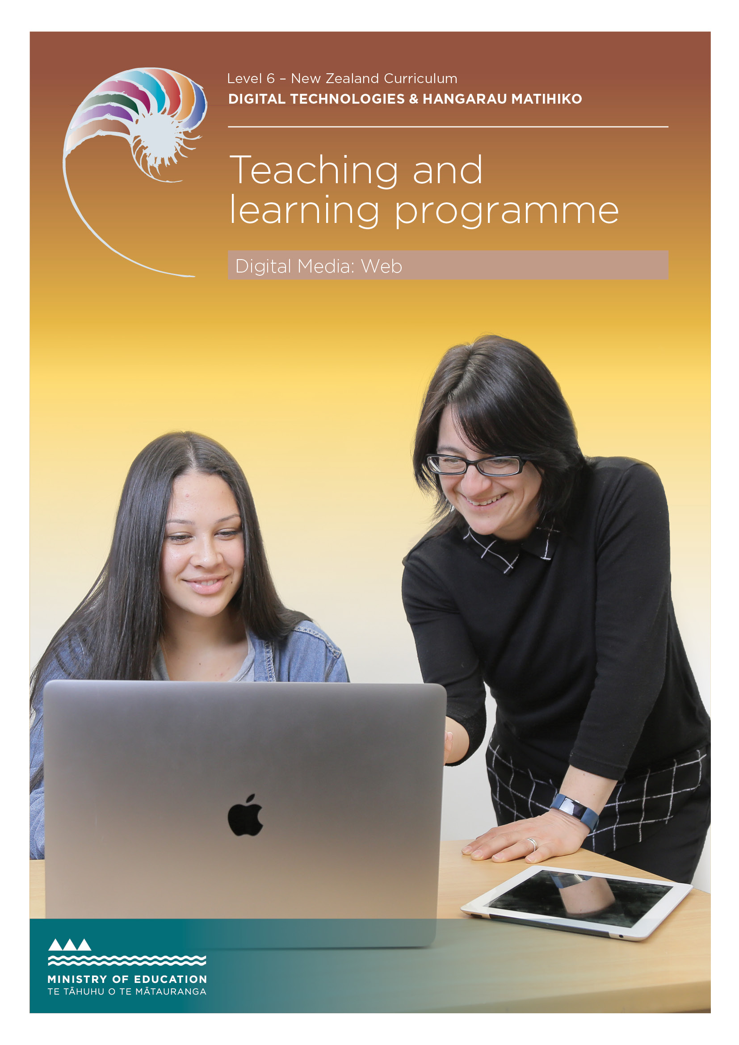

Developed by Jennifer Gottschalk, Whangaparaoa College, 2018
External links to websites
The Ministry of Education does not accept any liability for the accuracy of information on external websites, nor for the accuracy or content of any third-party website accessed via a hyperlink from this resource. Links to other websites should not be taken as endorsement of those sites or of products offered on those sites. Some websites have dynamic content, and we cannot accept liability for the content that is displayed.
Published 2018 by the Ministry of Education PO Box 1666, Wellington 6011, New Zealand
www.education.govt.nz All rights reserved Copyright © Crown 2018

Summary of teaching and learning programme
This programme uses the pedagogy of ‘flipped learning’. It is based around an eBook tutorial that includes embedded video. Students are provided with detailed instructions and walk- throughs showing how to create a fully functioning, refined website using HTML and CSS. No prior coding knowledge is assumed and all the software used is open source.

By the end of this teaching and learning programme, students will be able to:
- create a simple web page using HTML and CSS
- refine the website based on testing and user feedback.

Duration
Approximately 40 hours of teaching, learning and assessment. Teachers should adjust
this programme to suit their students and timetables.

Key teaching and learning concepts – the big ideas
- Websites can be created using HTML and CSS
- Both HTML and CSS should be validated to ensure that the final outcome is robust and future proof
- A well designed site is easy to use. Usability should be confirmed by doing simple usability testing.

Alignment to NZC and/or
Te Marautanga – (DTHM progress outcomes and progressions)
This material is focused on the designing and developing digital outcomes progression.
Students will:
- design and develop a basic web page
- ensure that their outcomes are easy to use (preferably by including some usability testing as part of the process)
- be ethical when it comes to designing and creating their outcome. Specifically they will honour copyright and will respect their users’ privacy.

Links to other learning areas
This programme involves documenting three books that students have read and could be used in conjunction with English achievement standard 90854.

Teaching and learning pedagogy
The programme uses ‘flipped’ learning, where the process has been videoed and students are encouraged to create their own practice websites by following the video tutorials.
They are also encouraged to go beyond the basics where possible. By using an eBook with video, teachers are free to work with individuals and troubleshoot in a way that would not be possible using more traditional methods. Teachers could encourage students to collaborate and work in small groups during their learning.

Prior knowledge and place in learning journey
No prior knowledge is assumed. If students have created websites before, this programme will help formalise their learning and also ensure that they develop good design (and coding) habits.

Resources required
- The learning resource. This is found in the ePub and support files. Note that this material includes ‘teacher only’ answers and a teaching guide. All of the resources can be found here.
- An internet connection
- A suitable text editor (using Brackets is one recommendation)
- A modern browser (Firefox is ideal, Chrome is OK, IE would be a browser of last resort as it does not have a developer console.)
- Access to a PHP environment. Using XAMPP (local host) is one option. This is highly desirable as it is needed for server side includes. If this is not possible, the resource can be adapted to use ‘straight’ HTML or javascript includes but this is less than ideal.
Software used:
- Brackets
- GIMP (for minor image editing)
- Firefox or Chrome
- Draw.io
- QiuReader (Mozilla) or Readium (Chrome).

How you might adapt this in your classroom
Any context where students make a multi-page website would work with this
programme. There are some opportunities for differentiation in the resource (eg, including javascript to filter or search a list of links).
Students should be encouraged to go beyond the basics if they have created websites before.

Assessment
See the assessment activity located at the back of this programme. The default task asks students to create a website reviewing three of their favourite foods or eating establishments. Achievement standard 91880 is used to assess this material.

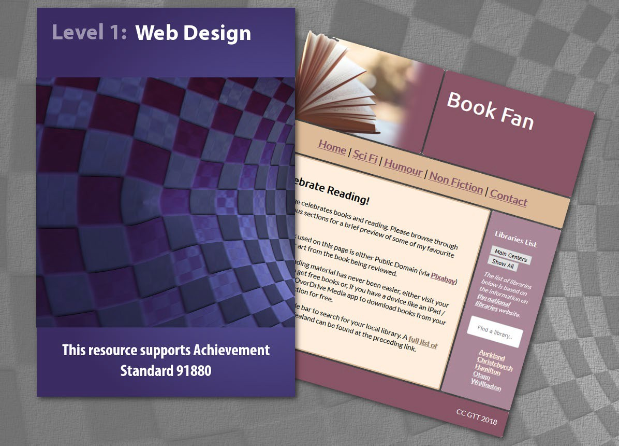

TERM OUTLINE

Term 1 | Week 1 | Week 2 | Week 3 | Week 4 | Week 5 | Week 6
Topics covered | Basic websites (91880)
Week plan | Basic layout | First page | Linked pages | Finishing touches | Assessment

Teaching and learning programme

What is being covered | Duration | Specific learning outcomes  Students will be able to: | Learning activities | Checkpoints | Resources
Basic web page layout | 5 hours | - create a plan for their site  - set up the basic  structure of the first page  - understand what iteration means  - identify end-user | - Download required software if using own device.  - Download ePub and support files.  - Set up folder structure.  - Create a wireframe for the site.  - Choose suitable colours.  - Check that the chosen colours are accessible to colour-  blind users. Use: https:// www.betterevaluation.org/en/ resources/tool/vischeck  - Learn how CSS works (including how to set up styles that affect multiple elements and how to target elements. For example, understand the difference between elements separated by commas and those separated by spaces).  - Use CSS grid to set up the page’s structure. | Checkpoint 1: Submit the following:  - Site wireframe (scan or screenshot)  and place in documentation template  - Screenshots showing that the site is accessible to colour blind users  - Screenshot showing the first page layout and evidence that the HTML and CSS validate. | Software Firefox Brackets  XAMPP (for PHP includes) Draw.io (wire framing)  Plugins (firefox) QiuReader FireShot  Pallete Generators: https://www.canva.com/color-palette/ http://www.palettefx.com/ https://labs.tineye.com/color/  Note: Use Palette FX and TinEye together to get a really good palette and the associated colour codes. Students could use Canva too as this is an easy way to show that they have considered alternatives and chosen the best option.

What is being covered | Duration | Specific learning outcomes  Students will be able to: | Learning activities | Checkpoints | Resources
Create index page | 5 hours | - create the first page of the site. | - Create the first page of the site.  - Put content into the banner, navigation, main part, side bar and footer.  - Validate both the HTML and CSS.  - Optionally use Javascript to allow users to filter or search for their local library. | Checkpoint 2: Submit the following:  - Screenshots showing how you have refined your page  - Your completed index page  - Evidence that the HTML and CSS validate.  Teacher note: you could ask students to submit their code instead of a screenshot but screenshots are quick to mark and should give an indication  of whether students have done the required work. | ePub and documentation template

What is being covered | Duration | Specific learning outcomes  Students will be able to: | Learning activities | Checkpoints | Resources
Linked pages | 5 hours | - create the contact page and other site pages. | - Create server side includes for content that will be common on all pages. For example, banner, logo, navigation and footer. If you can’t access a PHP environment, consider using Javascript to do this. You don’t have to use includes for  common content, but not doing so makes editing the navigation and common content extremely inefficient and inconvenient.  - Use Google Forms to create a contact form. Students should show the difference between the new “ugly” form and the better old form. Note that if they use email validation on the new form, they can’t revert to the old form which could be problematic.  - Edit Google’s embed code and style the form so that the HTML validates and the form displays correctly on the page.  - Test the contact form.  - Then develop the remaining site pages using the index page as a template. | Checkpoint 3: Submit the following:  - A link to your documentation. This should include evidence of refining your contact page.  - Screenshots (or a screencast) showing that your pages all display correctly. You should also be able to confirm that all your HTML validates. You should provide proof that your contact page validates.  Teacher note: Generally I will take a student’s word that their HTML validates and will spot-check  pages. If the contact page validates, usually the rest of the pages are fine too. If you do want to spot check student code, ask them to submit their code as well as the associated screenshots (it will take longer to mark). | ePub and documentation template

What is being covered | Duration | Specific learning outcomes  Students will be able to: | Learning activities | Checkpoints | Resources
Finishing touches | As needed | - complete the website and refine where necessary. | - Ask a volunteer to test the page’s usability.  - Make notes on anything that requires changing (Document this on your template in the form of a series of ‘before’ screenshots under suitable headings.)  - Make the changes!  - Provide ‘after’ screenshots on your template and write one or two line notes or justifications where necessary. | Checkpoint 4: Practice site  Submit your practice site and documentation which should include the results of your usability testing. | Usability ‘script’
Assessment | Two weeks | Create their websites and associated documentation

ASSESSMENT TASK

Achievement standard: 91880
Standard title: Develop a digital media outcome
Total credits: 4 credits

OVERVIEW
This assessment activity requires you to use appropriate tools, techniques and design elements to develop a website.
HOW WILL YOU BE ASSESSED?
You are going to be assessed on how successfully you design, implement and refine your website.
TASK
Plan, design and create a website for the following scenario:
Scenario:
Your website should review three of your favourite foods with an explanation of what you love about each dish. There are three reviews that you can use as a scaffold for inspiration in Appendix A. DO NOT include any recipes in your site.
On each page you should include a photograph of the dish – preferably one that you have taken yourself. Alternately, you may use Public Domain / Creative Commons images provided they are attributed appropriately. You should include links to all images that you use (that you have not taken yourself) at the end of your evidence template.
If you use original images, you should make it clear that the work is original and should mention the camera that you used and explain how, where (and why) you took the photos. You can easily do that as part of your review.
Your website must:
- have clear navigation
- allow users to contact you if they wish
- be formatted so that it is easy to read
- include a custom stylesheet
- be tested on a range of screen sizes and browsers.

ASSESSMENT TASK

Achievement standard: 91880
Standard title: Develop a digital media outcome
Total credits: 4 credits

TASK (continued)
You also need to provide documentation showing:
- Purpose and end-user considerations.
- Site refinement. During the development of the site, you will be expected to apply ongoing testing procedures to improve the quality and functionality of the site. When this happens, please include ‘before’ and ‘after’ screenshots explaining what you did and why, and how this improved the quality and functionality of the site.
Please provide evidence of iterative improvement through design, development and testing.
- Testing. Screenshots or a screencast showing that the site has been tested and works as expected. If you have made changes to your site based on usability testing, provide a brief statement explaining what has been changed. If possible, please provide before and after screenshots to show how the site has been improved.
Testing can be done by making a brief screencast showing the outcome being comprehensively tested. If desired, you can take screenshots of your screencast and annotate them. This is often easier than trying to ‘take a’ screenshot while testing where it is easy to ‘forget’ to screenshot a key part of the test. If you prefer, you are welcome to talk us through your testing and simply submit a brief screencast (screencasts should be 3 minutes or less in length).
- Implications that have been described, considered and addressed in the development of your website. For example, this may include a discussion on how your outcome:
  - is suitable for the intended audience
  - is socially / culturally acceptable
  - honours legal, ethical and intellectual property obligations
  - is accessible, usable and functional.
HAND IN
- Your website files
- Any supporting documentation

APPENDIX A – SAMPLE DATA

Smoked salmon omelette
This is a Sunday morning event and is one of my favourite foods. The omelette is made with one egg and filled with a generous serve of smoked salmon and cream cheese. In summer, the addition of fresh chives makes this meal extra-special. It is normally served with two slices of wholemeal toast and butter.
I took the photo on this page using my iPhone and was careful to make sure that there were no harsh shadows as I wanted the image to do justice to the dish.
Rating: 5 stars

Filo chicken ‘pie’
This winter treat includes roast chicken, mixed stir-fry veggies and a delightful sauce. It is topped with crumpled up filo sheets and a generous sprinkling of sesame seeds. This ‘pie’ is really tasty and is best served piping hot. It is one of my mother’s signature dishes, which means that if I give it anything less than a five star rating, things will not end well.
Rating: 5 stars

Affogato
For the uninitiated, affogato is basically a scoop of vanilla ice cream ‘drowned’ in a shot of hot espresso. This combines two of my favourite things, ice cream and coffee. Provided the coffee (and ice cream) are of high quality this is the ultimate simple dessert. I tend to have this one when ‘out’ and depending on the restaurant, the rating varies from a barely passable 3 stars to a more appropriate 5 stars.
Rating: 3–5 stars (depending on the restaurant)

TEACHER GUIDELINES

The following guidelines are supplied to support teachers/kaiako to carry out valid and consistent assessment using this internal assessment resource.
Teachers/kaiako need to be very familiar with the outcome being assessed by the achievement standard. The achievement criteria and the explanatory notes contain information, definitions, and requirements that are crucial when interpreting the standard and assessing students/ākonga against it.
Please be aware that NZQA have read the assessment task but the task will still need to be checked by the teacher using the assessment to ensure it meets all requirements.
CONTEXT/TE HOROPAKI
The assessment activity requires students to develop a website using appropriate tools, techniques and design elements. Please see the student task for more details. Teachers are encouraged to edit this default task to make it suitable for their community.
Please allow students to either complete the default task (see student task) or ‘pitch’ an alternative idea. Provided their idea allows them to use suitable techniques to create a website, they should be encouraged to develop their custom solution.
CONDITIONS/NGĀ TIKANGA
It is recommended that students should have at least two identified checkpoints with their teacher as they work through this assessment activity, to ensure that they have an opportunity to ask questions and gather feedback.
The format of the final outcome is a website.
Conditions of Assessment related to this achievement standard can be found on http://ncea.tki.org.nz
RESOURCE REQUIREMENTS/NGĀ RAUEMI
Students will need access to the web, a text editor (such as Brackets), image manipulation software such as GIMP or Photoshop. If they have opted to use server side as suggested by the resource that accompanies this assessment, then they also need access to a suitable hosting environment. This could involve giving students access to a php server or using something like XAMPP (and localhost).

ASSESSMENT SCHEDULE

EVIDENCE/JUDGMENTS FOR ACHIEVEMENT/ PAETAE | EVIDENCE/JUDGMENTS FOR ACHIEVEMENT WITH MERIT/KAIAKA | EVIDENCE/JUDGMENTS FOR ACHIEVEMENT WITH EXCELLENCE/KAIRANGI
Develop a digital media outcome. | Develop an informed digital media outcome. | Develop a refined digital media outcome.
The student has:  - used appropriate tools, techniques and design elements for the purpose and end-users of the outcome  For example (partial evidence – outcome does not need to include everything in the list be- low):  The student has created a website using HTML with an external stylesheet. The material is structured and formatted using a range of tags and styles (ie, it has clear headings, body text and lists or bullets if required).  The student has created font, colour and heading styles in their CSS that are appropriate for the purpose and end-users. They have added images to improve the design and provide balance to the text.  The student has commented their HTML or CSS files. | The student has:  - used information from testing procedures to improve the quality and functionality of the outcome  For example (partial evidence):  The student has compressed the images to ensure they load quickly.  The student has previewed the outcome, and made changes to the layout and formatting, and edited the stylesheet and created additional classes to improve it.  The student has asked a volunteer to use their site and made changes based on volunteer feedback.  The student has previewed the site using a slightly smaller (or larger) screen and adjusted the layout to ensure that the site looks acceptable on range of wide-screen devices.  The student has use HTML and CSS validation tools and fixed reported errors to improve the functionality of the website. | The student has:  - shown iterative improvement throughout the design, development and testing process.  For example (partial evidence):  The student carried out testing at key points during the design and development of the website to ensure that it was fit for purpose and easy to use.  For instance, they have checked:  - that navigation was easy to use  - that the material was easy to read and understand  - that the various pages looked acceptable in two unrelated browsers at two different  wide-screen resolutions  - that there were no redundant styles in their CSS to improve functionality and maintenance of the website.

ASSESSMENT SCHEDULE

The student has:  - applied appropriate data integrity and testing procedures.  For example (partial evidence):  The student has explained that copyright should be honoured and images should be credited (but they might not have done this appropriately in the outcome)  They have mentioned that the site should be accessible for colour-blind and visually impaired users but have struggled to make their site accessible.  They have stated that their site should be easy to navigate (for A, the site may have minor navigation issues). | The student has:  - addressed relevant implications.  For example (partial evidence):  The student has credited the source of their images (or made it clear that the images are original).  They have ensured that all their images have ‘alt’ tags or descriptions so that the material can be read out by screen-readers (and is thus accessible to visually impaired users).  Site is easy to use or navigate.  The site’s styles enhance the readability and compliment the aesthetic appropriate for the purpose and end-user. | The student has:  - applied design elements effectively.  For example (partial evidence):  The site is easy to read (has sufficient contrast).  The site makes effective use of repetition (eg, images are styled in a similar way so the pages are all consistent). Fonts and colours have  repeated throughout the site so that the pages are consistent.  Site makes good use of alignment and proximity. Related elements are close together and the layout is such that the site is aesthetically pleasing and easy to use.
Final grades will be determined on a holistic examination of the evidence provided against the criteria in the achievement standard.
All supporting materials are supplied with this programme and can be found on the TKI website.

