Year 11
Electronics

This workbook focuses on Physics / Electronic concepts and breadboard interfacing techniques. It helps students when working towards the following Achievement Standards: AS1.5 Develop an Electronics Outcome (6 Credits)

- Interfacing Electronic Components
- Debugging Embedded Software code
- DC Circuit Theory

1 Microprocessors

What is a Microprocessor  The Microprocessor is an integrated circuit that contains all the functions of a computer, however it is inside a single Integrated Circuit package and is way smaller  :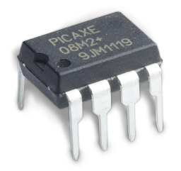  It includes three things:  - Data and program storage  - Input & Output control circuits  - A central processing unit that carries out simple maths on the data) | Pinout Diagrams  Pinout diagrams refer to a list of the Input and Output Pins of a Microprocessor. If tells us how many pins, what they are called and what the pins purpose or function is.  Below is the Pinout Diagram for the PICAXE 08m2 Microprocessor  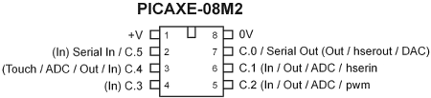  As you can see from the diagram, not every I/O pin is created equal. Operating Voltage for the PICAXE 08m2 is between 2.3v - 5v
- What 3 things does a microcontroller include?
_______________________________________________________________________________
_______________________________________________________________________________
- Which pin on the 08m2 is an input pin only?
_______________________________________________________________________________
- What is the Maximum voltage you can supply a PICAXE 08m2 Microprocessor?
_______________________________________________________________________________

2 Inputs, Processes & Outputs

The diagram shows how inputs, processing and outputs work within a typical electronic system

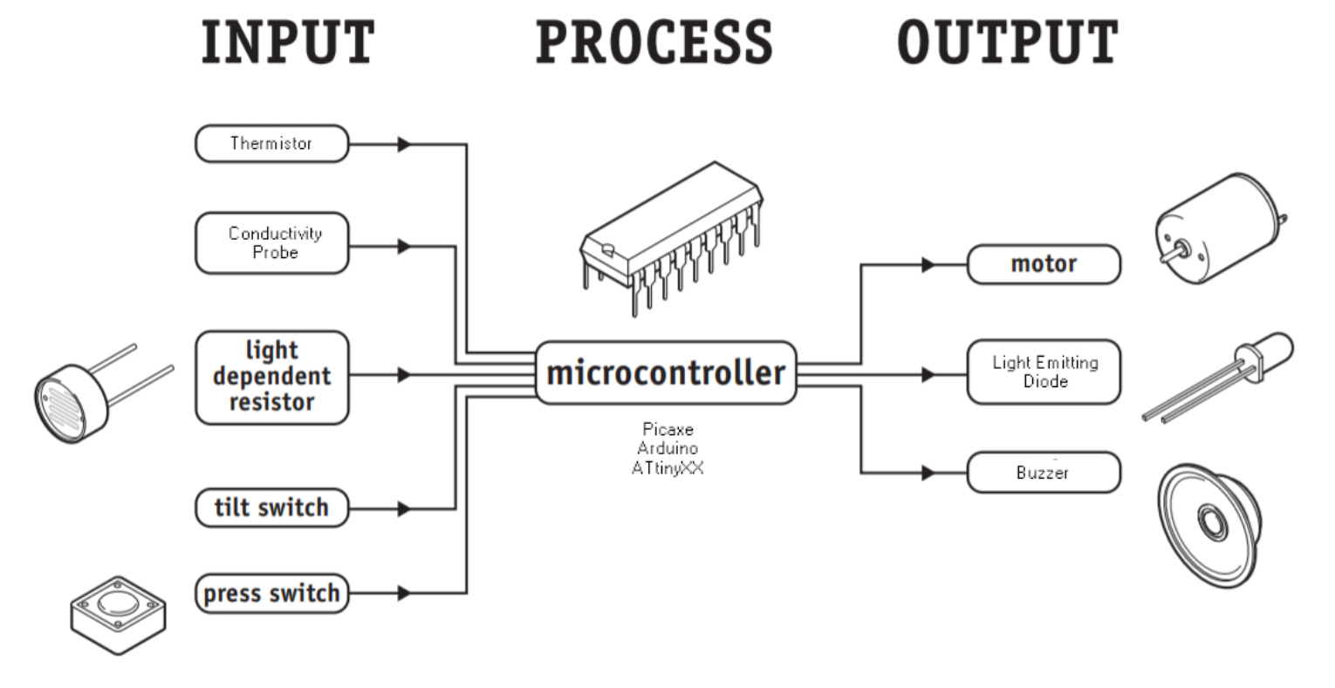
Inputs  Circuits convert physical world inputs (like Touch, Light, Temperature, Moisture Level, Water Level, Movement) to electrical voltage signals which are processed by a microcontroller. These physical world inputs are sensed using electronic components.  - Thermistor will sense temperature  - Light Dependant resistor (LDR) will sense light levels  - Conductivity Probes sense moisture  - Tilt switch will sense movement | Processes  The electrical signals sent to a microcontroller to be processed. A Microprocessor reads input, makes decisions are then turns output pins on or off.  Outputs  Outputs include devices such as Lights LEDs, Motors, switches, speakers or buzzers to make sounds. Even sending data via Infrared or Radio Transmission (these are outputs)

Input, Process, Output | Exercises

- Complete the Crossword
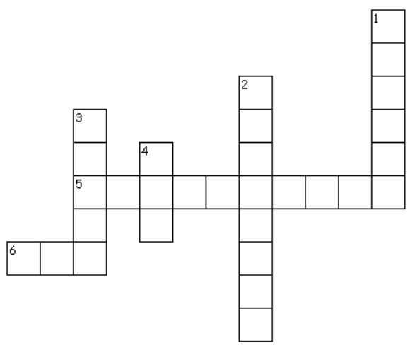 | Across  5. An electronic component that measures temperature  6. An electronic component that senses Light level  Down  1. An output device that makes sound  2. A microprocessor does this after taking in an input signal  3. An output device that rotates an axle  4. An output device that creates light of various colours
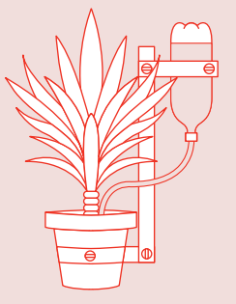
- List the inputs and outputs that could be used in the following plant watering electronic system (use your imagination)
_____________________________________________
_____________________________________________
_____________________________________________
_____________________________________________
_____________________________________________

3 Development Boards
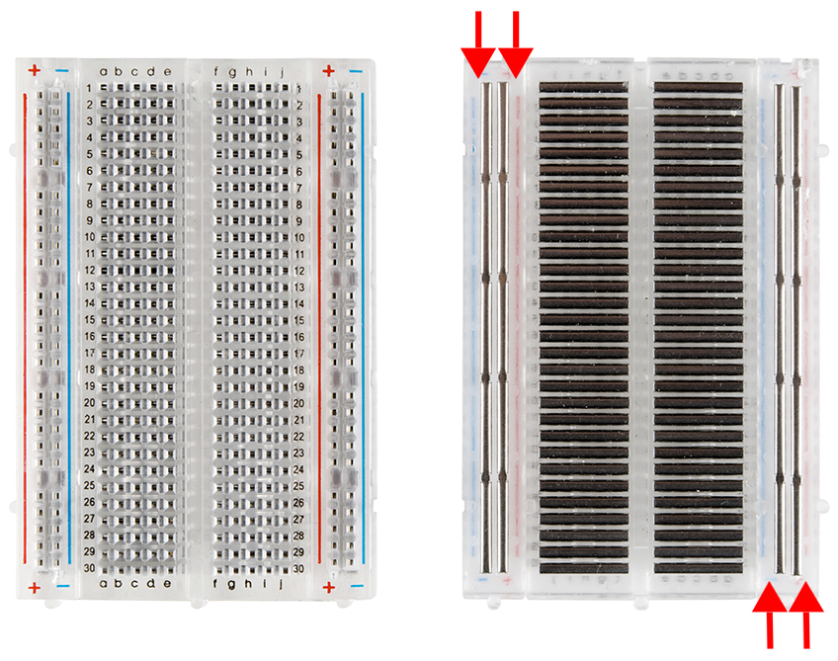

Breadboards
Breadboards are one of the most fundamental pieces needed
when learning how to build circuits. We use a Solderless Breadboard to quickly and easily interfacing electronic components. Breadboards have many holes, each hole is connected to the many metal strips that are running underneath.

The Development Board
This board for this course ares set up with:
- A Microprocessor
- A Battery Pack (4.5v or 6v)
- A Download or Program cable

The Boards shown below have are coloured with Red and Black stripes to indicate Vcc (Positive, Red) and GND (Negative, Black)
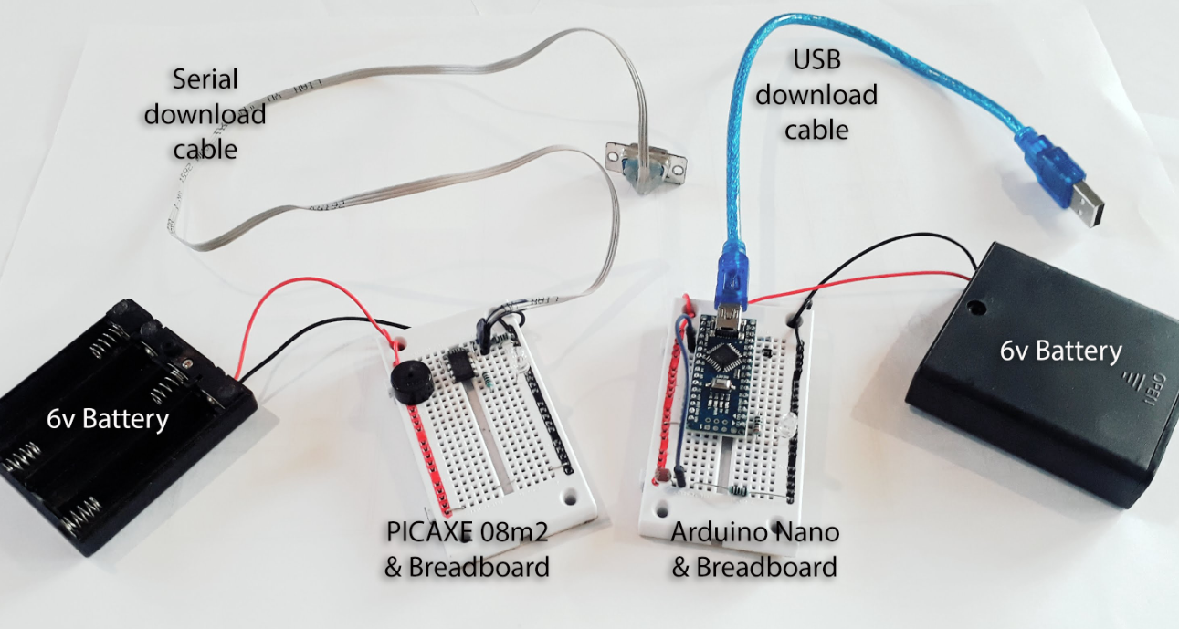

The PICAXE 08m2 & Breadboard  The PICAXE 08m2 Microprocessor requires specific resistors to help connect the PC programming cable. | The Arduino Nano & Breadboard  The Arduino Nano uses a direct USB wire to both Power and Program the Microprocessor. The Nano has further features including a 5v voltage regulator, LEDs to indicate downloading.

4 Batteries | Voltage & Current
Cells  A Cell in a single battery that stores chemical energy. converting this chemical energy into electrical energy for use in a circuit. When a battery is connected in a circuit drives a “direct current” flow around a circuit.  Circuit Symbol for Battery Cell  The circuit symbol for a cell is a long and short line. Note the negative or ground terminal is the smaller.  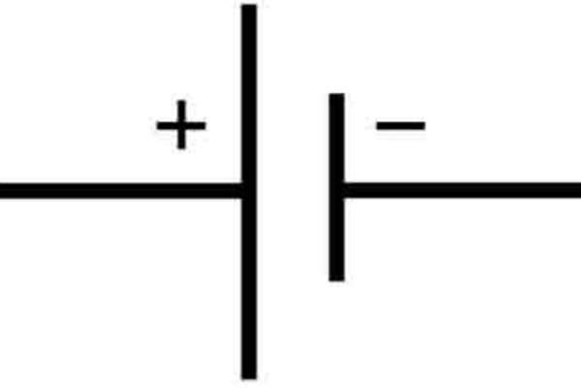 | Voltage  Voltage is a measure of the amount of energy between two points in a circuit.  - Voltage (V)  - measured in volts (v)  Current  Current is a measure of how fast energy is flowing around a circuit.  - Current (I)  - Measured in Ampere of Amps (A)
Battery Packs
We have a number of options for Power supplies ranging from 3v coin cells, to arrangements of 1.5v AA batteries.

Coin Cell  3v  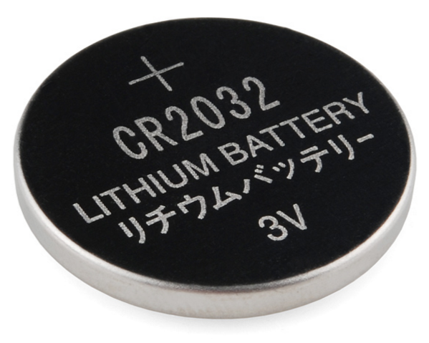 | 2x AA Battery Pack  3v  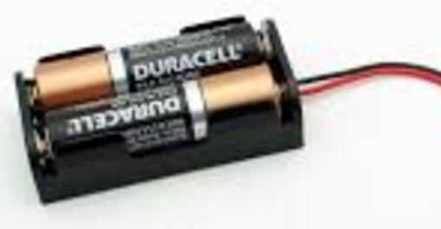 | 3x AA Battery Pack  4.5v  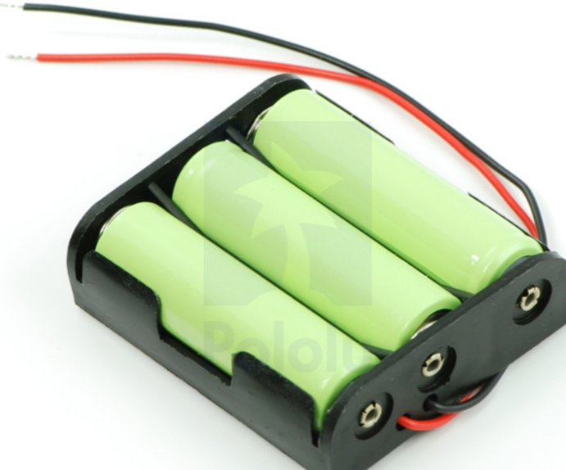

Batteries, Voltage & Current | Exercises

- Unscramble each of the words
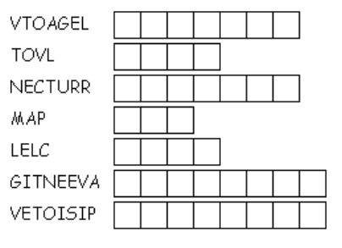

- Complete the table below to review Voltage and Current ideas
Electricity Concept | Unit of Measure | Unit Symbol
Voltage | ?? | ??
Current | ?? | ??

- Sketch the circuit symbol for 3 x AA Battery Cells joined together. What is the total voltage 3xAA battery will supply to a circuit?

- State the voltage of an AA battery, including unit
_______________________________________________________________________________
- Research and find out the voltage of an AAA battery, including unit
_______________________________________________________________________________
_______________________________________________________________________________
- Describe the difference between an AA and a AAA battery
_______________________________________________________________________________
_______________________________________________________________________________
_______________________________________________________________________________

5 Resistors

A resistor is a component that resists the flow of electrical current in a circuit. Resistors convert electrical energy to heat  - Resistance (R)  - Measured in Ohms (Ω) | Circuit Symbol for Resistor  The circuit symbol for a resistor is a rectangle.  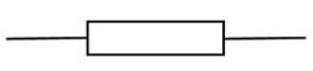
We will use a few sizes of resistor. Small values 330Ω, 470Ω, Medium Values 1000Ω or 1kΩ, 10,000Ω or 10kΩ, Large Values: 1,000,000Ω or 1MΩ

Resistance | Practical Exercises

- Write your own definition for Resistance in one short sentence
_______________________________________________________________________________
_______________________________________________________________________________
_______________________________________________________________________________
- What is resistance measured in, Unit and Symbol
_______________________________________________________________________________
- In electronics we use k for kilo ohms when talking about resistor sizes. Complete the table to convert from Ohms to kilo ohms and back again
Value in ohms | Value in kilo-ohms (kΩ)
?? | 1kΩ
2000Ω | ??
4700Ω | ??
?? | 12kΩ

- Find the key words in the word search
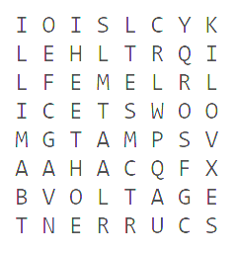 | AMPS  BATTERY  CELL  CURRENT  KILO  MEGA  MILLI  OHMS  VOLTAGE  VOLTS
- Crossword with key words and definitions
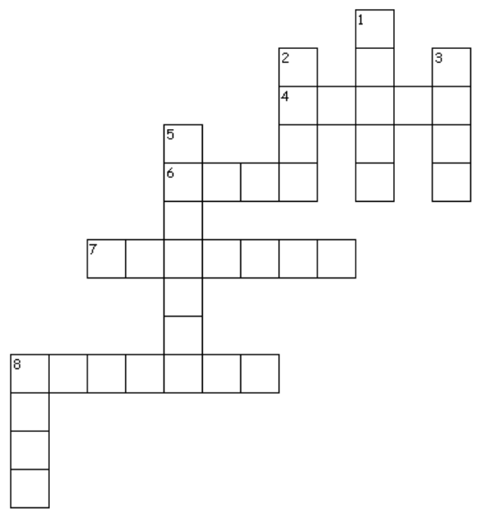 | Across  4. means a thousandth or divide by 1000  6. the unit of measure for resistance  7. converts chemical energy into electrical energy  8. the flow of energy in a circuit  Down  1. the unit of measure for Voltage  2. The unit of measure for Resistance  3. means 1000 or times by 1000  5. the energy a battery has  8. a single battery

6 Circuit | LED Interface

The first circuit to construct is an output circuit using a LED and a resistor. We call this circuit an interface because is has two electronic components that work together to allow the circuit to function

LED Interface  Construct the LED interface circuit  - 5mm Light Emitting Diode (LED)  - 330 Ohm resistor. | 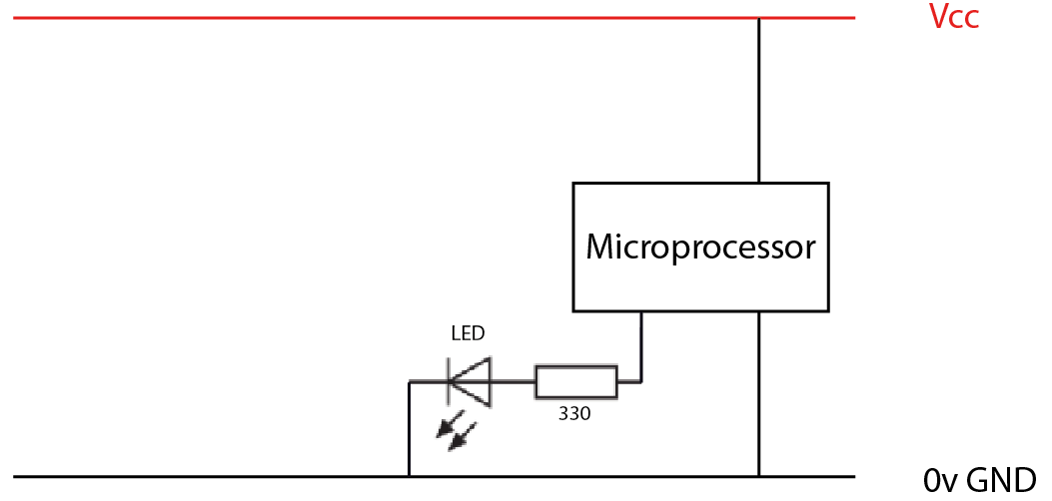

PICAXE Code

' Flashing LED.bas

setup:
symbol LED = C.2

do
high LED
pause 1000
low LED
pause 1000
loop

Light Emitting Diode | Practical Exercises

- Listen to the Morse Code sound https://en.wikipedia.org/wiki/SOS It is a signal for Help. Make the LED flash a morse code SOS. 3 short flashes, 3 long flashes and then 3 short flashes.
- The human eye is unable to detect flashing LEDs when they flash two fast. Decrease the rate of flashing down to a small pause of around 50ms. Can you detect the flash? If so, decrease the pause even further until you can no longer see the LED flash.

7 Series Circuit Theory

The LED circuit we just created “6 Circuit | Light Emitting Diode” is an example of a Series circuit. The LED and Resistor are connected one after the other.

A Series Circuit the Science way  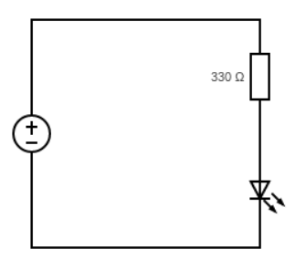  The circuit diagram below shows a power supply connected in line with a 330 Ohm resistor and an LED. These components are in Series.  A Series Circuit the Electronics Way  In electronics, components such as the resistor and LED may be connected to a digital output pin of a microprocessor instead of a power supply. All the same ideas apply. .  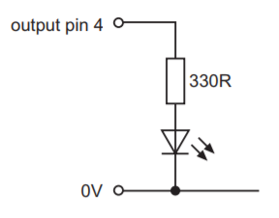 | Current in a Series Circuit  As there is only one path to follow, the current in a series circuit is the same everywhere. The current (I) through the resistor is the same as the current through the LED.  Voltage in a Series Circuit  Voltage is divided among the components in a series circuit. For example, if the battery in the circuit opposite supplies or gives 3v to the circuit, then the 3v would be divided among the resistor and LED  Example  A battery of Voltage: +6v is connected in a series circuit as shown opposite. The voltage loss across the resistor is: 4v  What is the Voltage across the LED?  V_{Battery} = V_{330R} + V_{LED}  V_{LED} = V_{Battery} - V_{330R}  V_{LED} = 6v - 4v  V_{LED} = 2 volts

Series Circuit | Exercises

- Check out the diagram opposite. It shows to resistors R1 and R2 in series. Calculate the voltage across the resistor R₂.  ( V_{TOTAL} = V₁ + V₂ ) … Series Circuit ____________________________________________________________________________________________________________________________________________________________ | 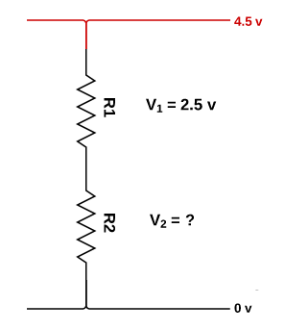

- Check out the diagram opposite. Calculate the voltage across the resistor R₁. ( V_{TOTAL} = V₁ + V₂ ) … Series Circuit  _________________________________________________________________________________________________________________________________________________________ | 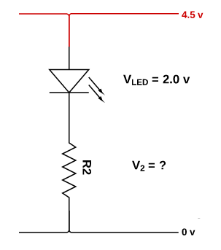

- Find the missing Current (I₁) in the series circuit. Include the unit.  __________________________________________________________________________________________________ | 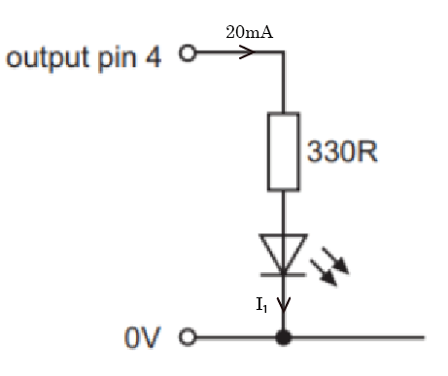

- Calculate the unknown voltage (V_{330R}) in the series circuit. Include the unit.  ___________________________________________________________________________________________________________________________________________________ | 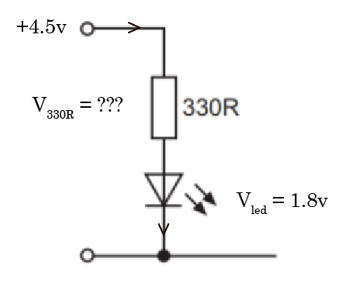

8 LED Characteristics
An LED stands for Light Emitting Diode. They are all around us; in our phones, in our torches and our TV’s. An LED converts electrical energy into light. LEDs require a lot less power to light compared to lamps or light bulbs. They don’t to get hot like lightbulbs do This makes them ideal for mobile devices and other low-power applications

Long Leg and Short Leg  LEDs, being diodes, will only allow current to flow in one direction. And when there’s no current-flow, there’s no light. The image below shows a 5mm LED. | Greedy LEDs  If you connect an LED directly to a current source it will try to dissipate as much energy as it’s allowed to draw, and, it will destroy itself. That’s why it’s important to limit the amount of current flowing across the LED with a small resistor.

An 5mm LED Datasheet
An LED Datasheet is a set of characteristics of a particular LED from the Manufacturer. The datasheet opposite gives minimum and maximum voltages across the LED for a current of 20mA.

LED | Exercises

- Sketch the circuit symbol for an LED

- Study the LED datasheet. What is the maximum and minimum voltages we should supply the LED
_______________________________________________________________________________
_______________________________________________________________________________
- What do you think happens if we supply more current or voltage than the LEDs maximum?
_______________________________________________________________________________
_______________________________________________________________________________

9 Circuit | Buzzer
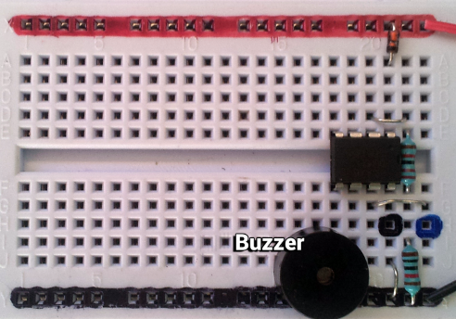
Construct the circuit using a Buzzer.
Make sure that the buzzer is connected into Pin 2 of the Picaxe.
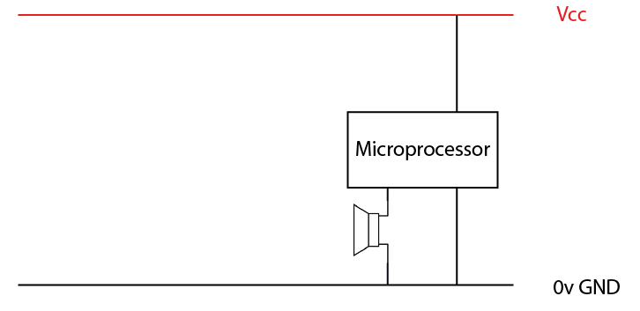

PICAXE Code

'Buzzer.bas

'assign all constants and variables
setup:
symbol BUZZER = C.2

' main loop
do
tune BUZZER,5,(1) ' tune pin, length, (low note)
pause 500 ' pause for 500 ms or half a second
tune BUZZER,5,(2)
pause 500
loop

Piezo Buzzer | Practical Exercises

- Make a piezo buzzer produce a ascending series of notes. From a low note to a high note.
- Find the lowest and highest notes that the piezo buzzer is able to produce. List them:
______________________________________________________________________________________________________________________________________________________________
- The tune command has 3 parameters. What does each parameter mean?
  - Pin______________________________________________________________________
  - Length ___________________________________________________________________
  - Note ____________________________________________________________________

10 Circuit | DC Motor Interface
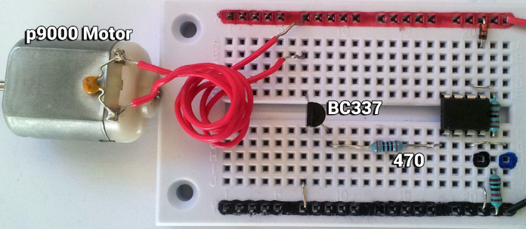
A DC Motor converts electrical energy into movement by rotating an axle. We call this circuit an interface because is has many electronic components that work together to allow the circuit to function
Motor Interface  Construct the Motor interface circuit  - DC Motor  - 470 Ohm Resistor  - BC337 Transistor | 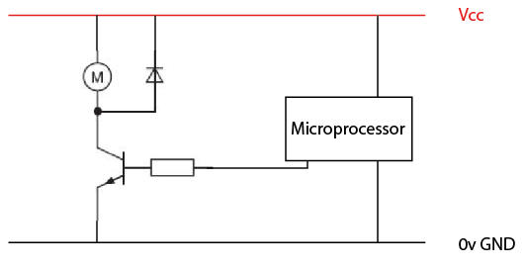

This diagram opposite will help to figure out how to connect the components. If the motor does not spin, first check the batteries on your board, then try placing a diode across the motor like the diagram above.

PICAXE Code

'Motor.bas

'assign all constants and variables
setup:
symbol MOTOR = C.2

' main loop
do
high MOTOR ' Turn Motor ON
pause 1500 ' pause ON for 1500ms or 1 and half seconds
low MOTOR
pause 500
loop

11 Transistor Switch
Motors need heaps of oomph, around 80mA - 120mA of current. We cannot connect the motor directly to the Microprocessor output pin as the current from a digital pin is too small, it does not have enough oomph (only about 20-40mA of current from an output pin). To enable us to control the motor we need to make use of the supply voltage. The diagram opposite shows how to connect a BC337 transistor as a switch in a way that allows the Microprocessor to “switch” the motor on and off.

What is a transistor?
The transistor is kind of like a water tap. The base pin is like a handle you might turn to allow more or less electrons to flow from emitter to collector. Transistors are three-terminal devices. The pins are labeled:
- collector (C),  - base (B), and  - emitter (E).  What is a transistor switch?  We use a transistor is to control the flow of current to another part of the circuit – using it as an electric switch. A normal switch would require a human hand turn it on or off, but a transistor switch is controlled by the voltage at the base pin. A microcontroller output pin, like those on a Picaxe or Arduino, can be programmed to go high or low, essentially switching a transistor on or off  Transistor | Exercises | 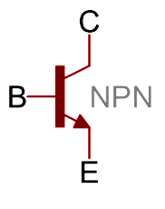
- Sketch the circuit symbol for a Motor

- Sketch Motor Symbol

- What happen if you swap the motor wires around the other way?
_____________________________________________________________________________
_____________________________________________________________________________

- Sketch the circuit symbol for a Transistor

- Why does a motor not work when connect directly into the digital output pins of the Microcontroller?
______________________________________________________________________________________________________________________________________________________________
- What needs to happen for the transistor to work like a switch? (current to flow from collector to emitter)
_____________________________________________________________________________
_____________________________________________________________________________
- Sketch the entire transistor switch interface (all components need to make the Motor go)

12 Circuit | Button
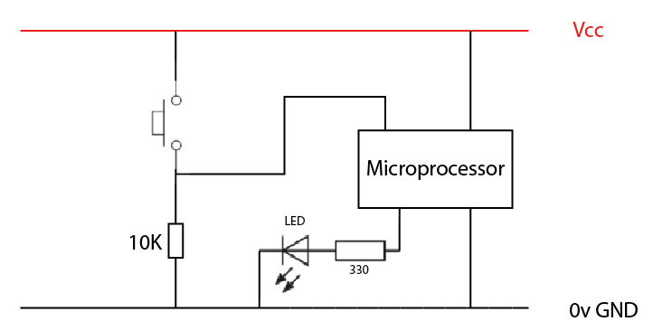
We call this button circuit an interface because is has two electronic components that work together to allow the circuit to function

Button Interface
Construct the Button interface circuit.

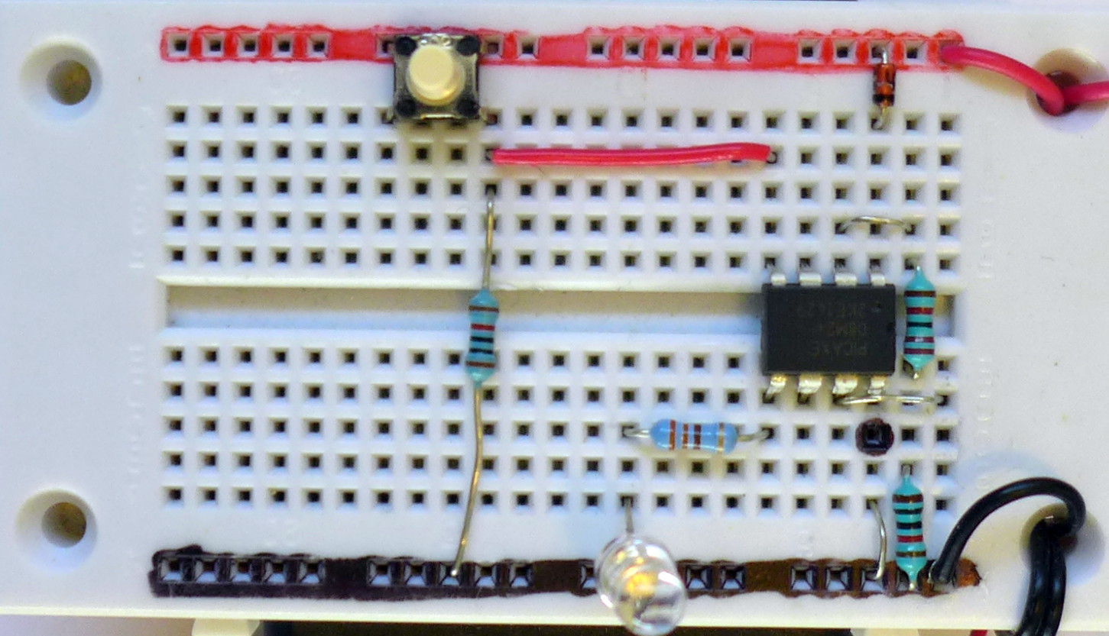
- Tact Switch (make sure it's plugged in with legs spread lengthways on the breadboard
- 10K Ohm resistor

Which way round does the tact switch go?
When pressed, a tact switch wll connect from point 1 to point 4 or from point 3 to point 2

PICAXE Code

'Button.bas

'assign all constants and variables
setup:
symbol BUTTON= pinC.3 ‘assign pinC.3 to the value BUTTON and set as input
symbol LED = C.2 ‘assign C.2 to the value LED

' main loop
do
if BUTTON= 1 then ‘ check is the button pin in a High or ON state
high LED ‘ set LED pin to High
Pause 100 ‘pause High for 100ms
else
low LED ‘ set LED pin to LOW
endif
loop

13 Button Interface

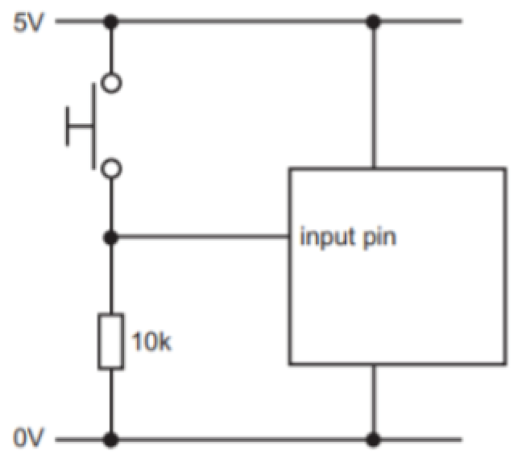
What is a button
A button is a switch, it is a used to interrupts the flow of current in a circuit. Switches are devices that are either completely on “closed” or completely off “open”.

The switch Interface
The switch interface uses a 10K resistor to pull the input pin of the Microprocessor to ground (A pull-down resistor). This means the digital input pin “feels” ground or zero or LOW. Only when the switch is pressed, does a connection get made to the positive rail, allowing the digital input pin to “feel” high.

Button | Practical Exercises

- Sketch the circuit symbol for a closed button interface

- What is the purpose of the pull-down resistor?
____________________________________________________________________________
____________________________________________________________________________
____________________________________________________________________________

13 Resistive Sensors | LDR

A Light Dependant Resistor or LDR is a light-sensitive, variable resistors. It changes resistance depending on the amount of light falling on the sensor.  In pitch-black conditions, the LDRs resistance will be in the megaohm’s (1.0MΩ+) range. Shining a bright light on the sensor can drop the resistance to near-zero, but usually the resistance of the LDR falls between 8-20kΩ in normal lighting conditions. | 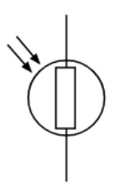

Resistive Sensors | Practical Exercises
Measure Resistance with a Multimeter  - We can Grab a multimeter, switch the dial to the Ohms symbol like the image opposite and use the probes to measure the resistance of the LDR in various light levels.  Light Level Resistance Value  Dark  Low Light  Classroom Light  Phone Torch Light | 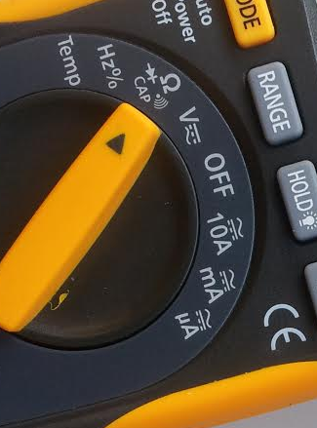  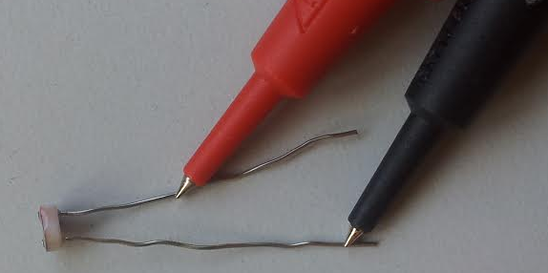

14 Circuit | Light Sensing interface
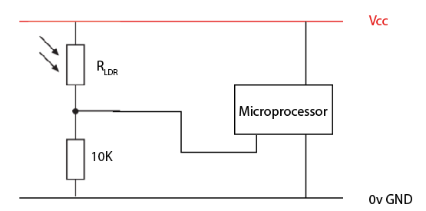
This circuit is an interface because is has two electronic components that work together to allow the circuit to function.

We can use the Light dependant resistors properties to help sense light levels. Construct the following circuit on a breadboard.

- LDR
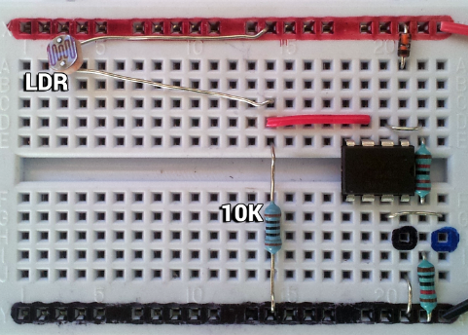
- 10K Resistor
- Jumper Wire to Microprocessor

PICAXE Code

'Read Light Levels.bas

'assign all constants and variable
setup:
symbol LDR = C.4 ‘ assign the LDR to analogue pin C.4

' main loop
do
readadc LDR,b1 ‘ read the voltage signal on the LDR pin
debug ‘ send all readings to a PC screen
loop

Light Sensing Interface | Exercises
- Refer to your debug screen. On the number line below, place in your readadc values for Darkness, Room-Lighting and Intense Light.

light level | Intense Light Classroom Lightening Darkness
 | 0 ----------------------------------------------------------------------------------------------------------------- 255
readadc value | ?? ___________________ |  |  | ?? __________________ |  |  |  | ?? ___________________
- Sketch LDR Symbol

- Sketch the Light Sensing interface. This is the combination of an LDR and 10K resistor. Label all components plus supply voltage and 0 volt rails

- Complete the word find with the key words
ANALOGUE
DARKNESS
LIGHT
MULTIMETER
OHMS
RESISTOR
SENSOR
VARIABLE

- Complete the Crossword
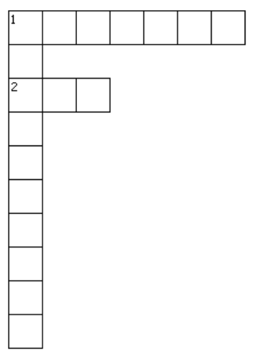 | Across  1. the approximate resistance of an LDR in Pitch Black conditions  2. A resistor whose resistance varies with light  Down  1. A device used to measure Resistance, Voltage, and Current

15 Circuit | Temperature Sensing Interface
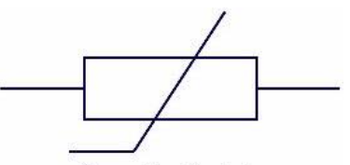
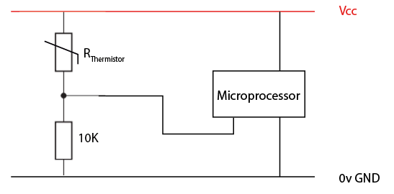
This circuit is an interface because is has two electronic components that work together to allow the circuit to function. A NTC Thermistor is a temperature-sensitive, variable resistors. It changes resistance depending on the amount of heat applied to the sensor. The resistance of NTC Thermistor will decrease as the temperature increases.

Construct the following circuit on a breadboard.
- 100k NTC Thermistor into C.2
- 10K Resistor
- Jumper Wire to Microprocessor

PICAXE Code

'Read Temp Levels.bas

'assign all constants and variable
setup:
symbol THERMISTOR = C.2 ‘ assign the Thermistor to analogue pin C.2

' main loop
do
readadc THERMISTOR,b1 ‘ read the voltage signal on the THERMISTOR pin
debug ‘ send all readings to a PC screen
loop

- What happens to the readadc value when you heat the Thermistor
_______________________________________________________________________________

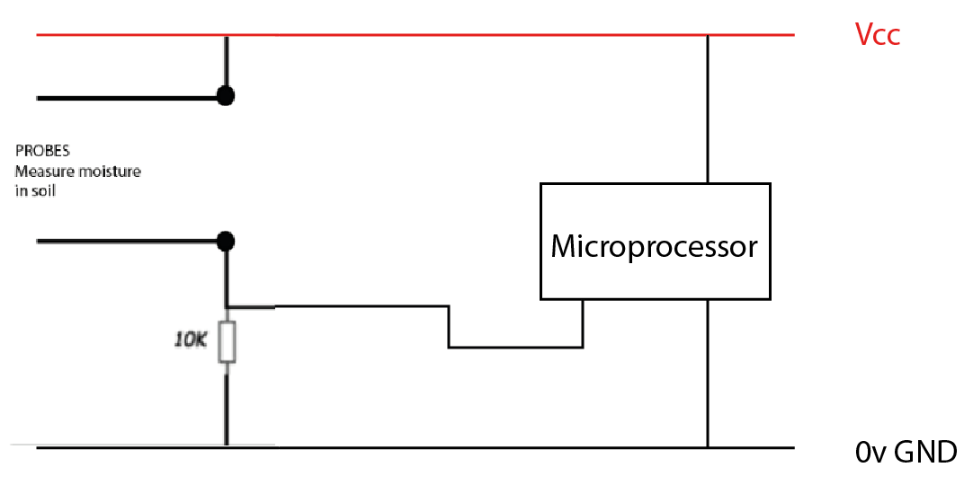
16 Circuit | Moisture Sensing Interface

This circuit is an interface because is has two electronic components that work together to allow the circuit to function.

Water is able to act as a conductor. The more water in soil the lower the soils resistance (resistance gets lower with an increase in moisture content) .We can use probes to help construct a circuit that responds to moisture levels.

Construct the following circuit on a breadboard.
- Two Jumper Wires as Probles
- 10K Resistor
- Jumper Wire to Microprocessor

PICAXE Code

'Read Moisture Levels.bas

'assign all constants and variable
setup:
symbol MOISTURE= C.2 ‘ assign the Moisture probes to analogue pin C.2

' main loop
do
readadc MOISTURE,b1 ‘ read the voltage signal on the MOISTURE pin
debug ‘ send all readings to a PC screen
loop

17 Making Decisions with Code

What does good code look like?
It's time we had a look at the code we are using to take in input, processes the input and control output devices. The image below shows the code we used for the Light sensing circuit.
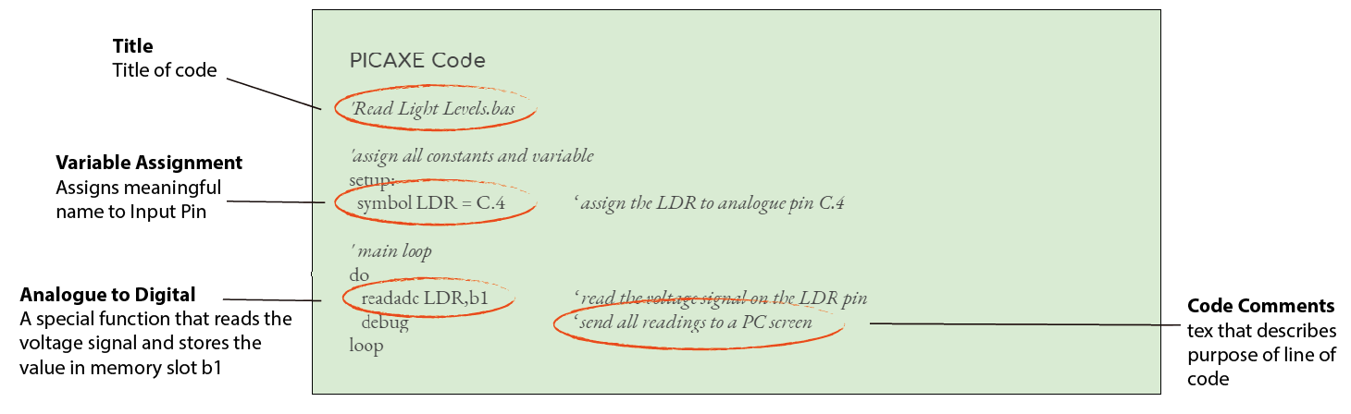
What your code needs to include  It is important that the code your write includes: Meaningful file name, Program Title, Code comments, Indentation, Variable assignment using symbols. | Why do we do this?  This make your code easier to understand, easier to read by other people and easier to debug (fix syntax errors and logic errors)

- When writing code, what should you include?
____________________________________________________________________________
____________________________________________________________________________
____________________________________________________________________________
____________________________________________________________________________
____________________________________________________________________________
- What is variable assignment?
____________________________________________________________________________
____________________________________________________________________________
- What are code comments?
____________________________________________________________________________
____________________________________________________________________________

Making decisions with code

Making decisions with code involves three things:
- Taking in and storing input
- Processing the stored input
- Turning on an output device

Below is example code that takes in and stores analogue input, processes the stored input then turns on an output device

PICAXE Code

'Read Light Levels.bas

'assign all constants and variable
setup:
symbol LDR = C.4 ‘ assign the LDR to analogue pin C.4
symbol LED= C.2 ‘ assign the LED to digital pin C.2

' main loop
do
readadc LDR,b1 ‘ read the voltage signal on the LDR pin

if b1 < 20 then ‘ if light value below 20 - flash LED for 50ms
high LED
pause 50
low LED
else ‘ else light value above 20 - flash LED for 1 sec
high LED
pause 1000
low LED
endif

loop

- In the code above, what input is being taken in? (Light or Temp)
____________________________________________________________________________
____________________________________________________________________________
- What 3 things does making a decision with code involve?
____________________________________________________________________________
____________________________________________________________________________
____________________________________________________________________________

One of the most important parts of this code is below. It takes in a voltage signal as input from a specific input pin and store it in memory
Taking in and storing input  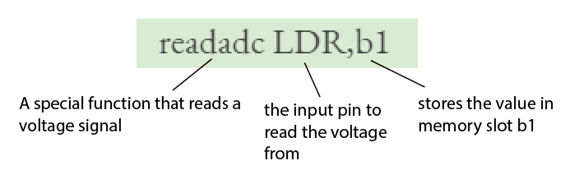 | Processing the stored input, Turning on an output device  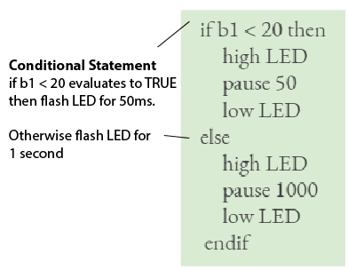

Conditional statements
A conditional statement is an if else command, and is used to make a decision. If condition is TRUE)then do something, else condition must have been FALSE so do something else

if “condition” then
// do something
else
// do something else
end if

Example show using a conditional statement on Digital and Analogue inputs
Check state of Digital Input pin  symbol BUTTON= pinC.3  if BUTTON = 1 then  ‘ do something  else  ‘ do something else  endif  - Does BUTTON = 1 refer to the switch open or switch closed?  ____________________________________________________________________ | Check value of variable  symbol LDR=C.4  readadc LDR, b1  if b1 > 100 then  ‘ do something  else  ‘ do something else  endif  - What happens if the statement if b1 < 100 evaluates to FALSE?  ____________________________________________________________________

18 Project | Scared of the Dark

Develop an electronics system that is able to sense nighttime and turn on some form of light

- Construct the LDR input interface. sketch and label the LDR analogue input interface

- Calibrate your LDR readadc values to light levels. Use a calibration table to record your light levels and readadc values.
Light Levels | Readadc values
Pitch-Black | ??
Darkness | ??
Low Light | ??
Med Light (Room Lightning) | ??
Sunlight | ??
Intense Light | ??

- Construct an output interface that will provide some form of light. sketch and label the input interface

- Write software code that takes in and stores input, makes a decision and turns on an output device. Debug your code (fix syntax errors logical errors)
- Test your software program to make sure it turns on a light in night time light conditions Use a testing table to record your light levels and light source response.
Light Levels | Did the light turn on?
Pitch-Black | ??
Darkness | ??
Low Light | ??
Med Light (Room Lightning) | ??
Sunlight | ??
Intense Light | ??

- Modify your Programming Code so that it includes: Meaningful file name, I/O pins assigned meaningful names using symbols, Program Description,code comments, Code indentation. Either Copy in your program code or glue in a photograph.

19 Project | Temperatures for Seed growth

What is the optimum temperature for seed growth? Temperature has a big effect on Seed Growth? Germination increases in higher temperatures – up to a point. Some plant seeds, including cool season vegetables like lettuce and broccoli germinate best in temperatures between 13 to 21 C.
https://www.gardeningknowhow.com/plant-problems/environmental/temperature-on-plants.htm
Develop an electronics system that is able to indicate to a gardner when the soil is within 13-21 C

- Construct the NTC Thermistor analogue input interface. sketch and label the input interface

- Calibrate your NTC Thermistor readadc values to temperature levels. Use a calibration table to record your temp levels and readadc values.
Temperature Levels | Readadc values
12ºC | ??
13ºC | ??
14ºC | ??
... | ??
20ºC | ??
21ºC | ??
22ºC | ??

- Construct an output interface that will provide some form of warning indicator. Sketch and label the input interface.

- Write software code that takes in input, makes a decision and turns on an output device. Debug your code (fix syntax errors logical errors)
- Test your software program to make sure it turns on a warning indicator in temperature conditions that are to cold or to hot. Use a testing table to record your light levels and light source response.
Temperature Levels | Did the warning indicator function as expected?
Below 13ºC | ??
13ºC | ??
Above 13ºC | ??
... | ??
Below 21ºC | ??
21ºC | ??
Above 21ºC | ??

- Modify your Programming Code so that it includes: Meaningful file name, I/O pins assigned meaningful names using symbols, Program Description,code comments, Code indentation. Either Copy in your program code or glue in a photograph.

20 Project | Fan Control
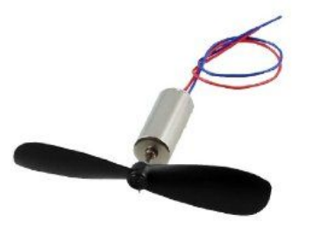
Desktop Fans are useful to help cool down areas by creating airflow. Your task is to construct a Fan that turns on when the Temperature measured by an NTC Thermistor increases above 21ºC.

- Construct the NTC Thermistor analogue input interface. sketch and label the input interface.

- Calibrate your NTC Thermistor readadc values to temperature levels. Use a calibration table to record your temp levels and readadc values.
Temperature Levels | Readadc values
Cold | ??
Perfect Temp (21 ºC) | ??
Hot | ??

- Construct an DC Motor output interface that will provide some form of airflow sketch and label the input interface.

- Write software code that takes in input, makes a decision and turns on an output device. Debug your code (fix syntax errors logical errors)
- Test your software program to make sure it turns on a warning indicator in temperature conditions that are to cold or to hot. Use a testing table to record your light levels and light source response.
Temperature Levels | Did the Fan function as expected?
Cold | ??
Perfect Temp | ??
Hot | ??

- Modify your Programming Code so that it includes: Meaningful file name, I/O pins assigned meaningful names using symbols, Program Description,code comments, Code indentation. Either Copy in your program code or glue in a photograph.

21 Voltage, Current, Resistance Review

Voltage  Voltage is a measure of the amount of energy between two points in a circuit. Voltage (V) measured in volts (v)  Current  Current is a measure of how fast energy is flowing around a circuit. Current (I) Measured in Ampere of Amps (A)  - 1 milli-Amp (1mA)  → 1 / 1000 = 0.001 Amp  - 100 milli-Amp (100mA).  → 100 / 1000 = 0.1 Amp | Resistance  Resistance is a measure of the resistance to the flow of charge. All wires and components have some resistance. In the process of resisting the flow of charge heat will be produced. Resistance R is measured in Ohms ( Ω ). We commonly use the following resistor values in this course  - 330 Ω, 470 Ω  - 1KΩ (1000Ω), 10K (10,000Ω)

Voltage, Current & Resistance | Exercises

- What is the unit for Current?
_____________________________________________________________________________________________
- Convert the following values to Ampere
  - 10mA : ___________________________________ ( divide by 1000 )
  - 25mA : ___________________________________ ( divide by 1000 )
  - 110mA : ___________________________________ ( divide by 1000 )

- What is the unit for resistance?
_____________________________________________________________________________________________
- What are common resistor values we use this course?
_____________________________________________________________________________________________
_____________________________________________________________________________________________
_____________________________________________________________________________________________
- What is produced in the process of resisting the flow of charge?
_____________________________________________________________________________________________

22 Voltage Divider
A voltage divider is the name given to two resistor in series, used for the purpose of dividing up the voltage from a power source. The diagram opposite shows a light Sensing interface with an LDR and a fixed resistor in series.

Its a series circuit!  - The LDR and fixed resistor are in Series  - In a series circuit the source voltage is divided among the resistors.  - The bigger the resistance of the LDR (such as in Pitch black) the higher the voltage across the LDR. | 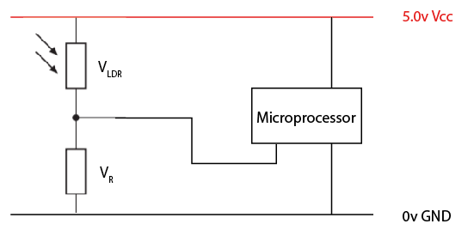

Let's look at an example:
The diagrams below show a Light sensor interface in Pitch Black and in Intense Lighting conditions.

Light Sensor interface values in Pitch Black  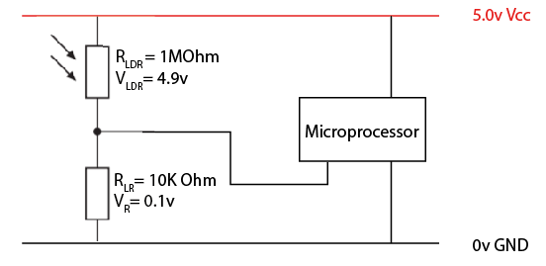The  LDR in Pitch black has a resistance of 1M Ohm. Thats really big. It uses up most of the voltage from the source due to the being so much bigger than the fixed 10K Ohm resistor. | Light Sensor interface values in Intense light  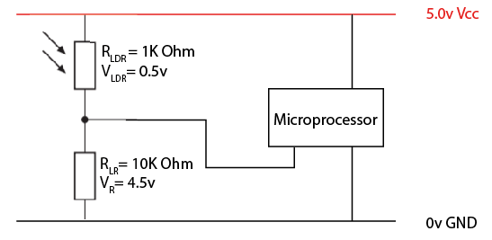The  LDR has a resistance of 1K Ohms in Intense Light. Much smaller. It uses a very small amount of voltage from the source due to the being so much smaller than the fixed 10K Ohm resistor.
Microprocessor can read the voltage signal from the LDR
The microprocessor is able to read the voltage signal from the LDR, converting it to an integer value. The bigger the voltage signal from the LDR, the bigger the integer value recorded. This is called Analogue to Digital Conversion. A PICAXE using a command called readadc for this.

Voltage Divider | Exercises

- A voltage divider is made up of how many resistors
_____________________________________________________________________________________________
- Is a voltage divider a combination of resistors in series or in parallel?
_____________________________________________________________________________________________
_____________________________________________________________________________________________
- Does an LDR have a large or small resistance in Pitch Black lightning
_____________________________________________________________________________________________
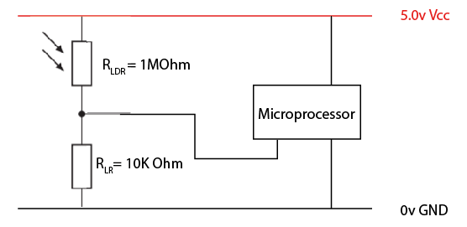
- In the diagram opposite
  - What is the source voltage
____________________________________
  - Which resistor will have the largest voltage across it? The 1M Ohm or the 10K Ohm
____________________________________
_____________________________________
_____________________________________
- What does a Microprocessor convert a voltage signal to when using Analogue to Digital conversion?
_____________________________________________________________________________________________
_____________________________________________________________________________________________

- A student has drawn a circuit diagram of a voltage divider that uses an LDR to measure light levels. Place in the following labels in there correct placed on the circuit diagram.  - R_{LED}  - R₂  - V_{out} | 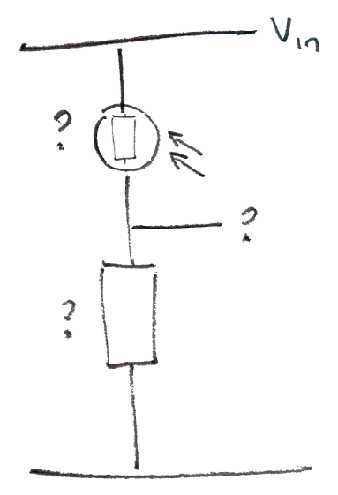

23 Processing a voltage signal
Microprocessors are great at processing a voltage signal, like those from a Light Dependant resistor. It can do this using a technical called analogue to digital conversion.

readadc command
readadc means read analogue to digital conversion and is a method of converting a physical voltage into a digital value. The readadc command will read a voltage signal and convert it to a value of between 0-255 from the microcontroller input pins. (assuming is stores values using 8-Bit binary)

readadc C.4, b1

Byte Variables
Every microprocessor has a certain number of general purpose variables to store data temporarily while the program is running. The basic unit of storage is the byte. Variables are containers that can hold data. We can use these byte variables to hold integer data types.

- let b0 = 100
- let b1 = 0
- let b2 = 255

But there are limitations. A byte variable can only hold a number between 0-255.

Testing with the debug command
Debug command sends information from the PICAXE back to the Picaxe Programming Editor displaying the current state of the byte variables. PICAXE > DEBUG (F6)

debug b1

This is useful with testing and debugging code. But it does slow the operation of your program down.  The diagram opposite show the Picaxe debug screen.  readadc 4, b1  debug b1 | 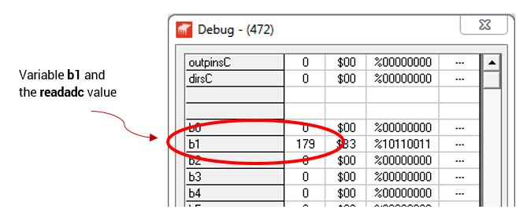

Processing a voltage signal | Exercises

- What does adc stand for? _____________________________________________________________________________
_____________________________________________________________________________

- The readadc command takes two parameters, what are they? _____________________________________________________________________________
_____________________________________________________________________________

- A PICAXE byte variable can hold values from 0 to what?
_____________________________________________________________________________
- What does the DEBUG command do?
_____________________________________________________________________________

24 Ohm's Law
Ohm's Law deals with the relationship between voltage, current and resistance in a circuit. This relationship states that The voltage across a resistor is proportional to the current through it. We end up with a little equation that links these ideas
Voltage (V) = Current (I) x Resistance (R)  V = I x R | 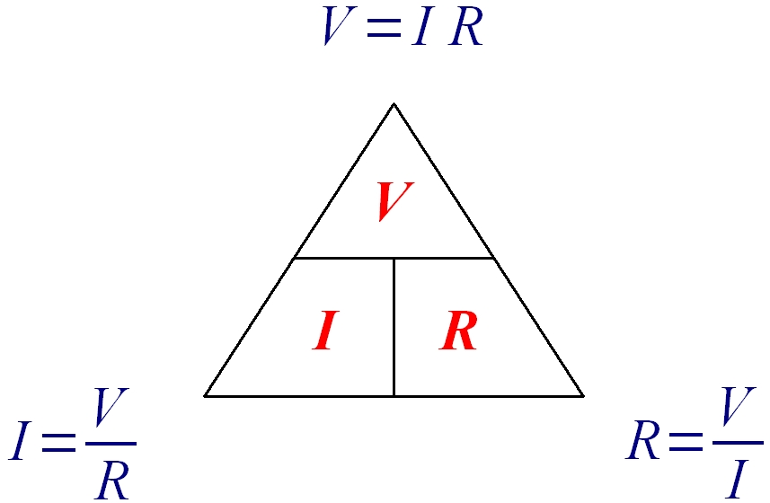

Example Calculation
An alarm clock draws 0.5 A of current when connected to a 120 volt circuit. Calculate its resistance.
Known are  - Current I = 0.5A  - Voltage V = 120v | How to solve the equation  R = V / I  R = 120 / 0.5  R = 240 Ohms

Ohm’s Law | Exercises

- A DC Motor uses a 3 x AA batteries (4.5v). What is the resistance of the DC motor if it draws a current of 0.1A?
_______________________________________________________________________________________________________________________________________________________________________________________________________________________________________________________________
- A circuit contains a 3 volt cell battery and a LED with a resistance of 60 ohms. Calculate the current.
_______________________________________________________________________________________________________________________________________________________________________________________________________________________________________________________________

25 Circuit | Digital Temp Sensor
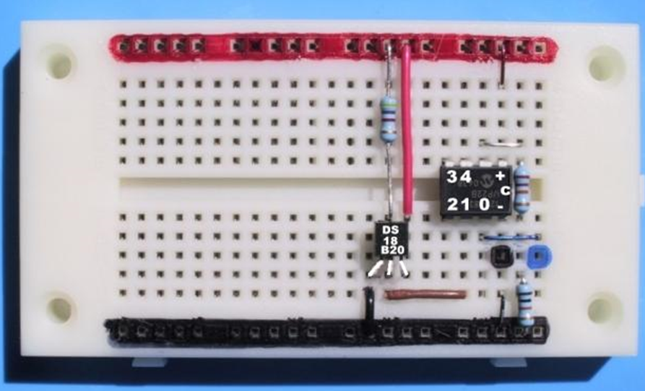
The DS18B20 is a sealed digital temperature probe lets you precisely measure temperatures in wet environments with a simple 1-Wire interface. Only one wire (and ground) needs to be connected from Picaxe

Notice a 4K7 (4,700 Ohm) resistor connected from the 1-Wire pin to Vcc

Construct the following circuit on a breadboard.

PICAXE Code

'Read Moisture Levels.bas

'assign all constants and variable
setup:
symbol TEMP= C.2 ‘ assign the DS18B20 probes to Digital pin C.2

' main loop
do
readtemp TEMP, b1 ‘ read the signal on the TEMP pin
debug ‘ send all readings to a PC screen
loop

Dallas Temp Sensor DS18B20 | Practical Exercises
The readtemp,PIN,BYTE_VARIABLE command will typically store values between 0-255. So how does it output negative temperature values?

- Using some ice, attempt to generate negative values on the DS18B20 temperature probe and record the output to the serial terminal.
- How could you use software code to output negative values to the serial terminal using the - sign

26 Components Review

Below are some specifications for typical low voltage DC components used.
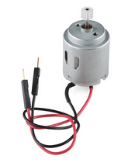 | Motor Specifications  The motor has a normal operating voltage range of 3.0 to 5.0V DC and with no load spins at a speed of 6600 RPM (drawing about 110mA).
- What is the maximum recommended voltage of the motor?
_____________________________________________________________________________
- How much current does the motor draw with no load?
_____________________________________________________________________________
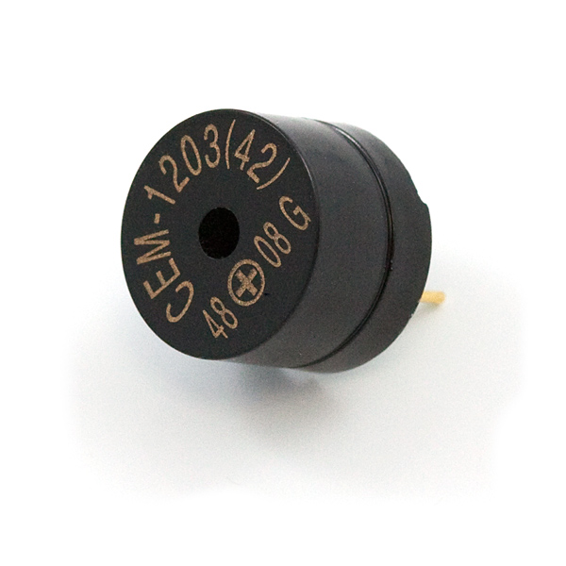 | Piezo Speaker Specifications  Each speaker requires an operating voltage of 3.5-5V with a current of 55mA max. These speakers also have a typical sound output of 95 dBA and a coil resistance of 42 ohms.
- What is the maximum recommended voltage of the Piezo Speaker?
____________________________________________________________________________
- How much current does the speaker draw?
_____________________________________________________________________________
Here are the recommendations
for a typical 5mm LED
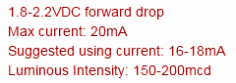
- What is the recommended Voltage for the 5mm LED?
_____________________________________________________________________________
- What is the recommended Current for the 5mm LED?
_____________________________________________________________________________
- What is likely to happen if your LED circuit is above or below these recommended specifications?
_____________________________________________________________________________
_____________________________________________________________________________

27 Current Limiting Resistor
Limiting current into an LED is very important. there is a specification for diodes called the forward voltage (usually between 1.5-4V for LEDs). You must reach the characteristic forward voltage to turn 'on' the diode or LED, but as you exceed the characteristic forward voltage, the LED's resistance quickly drops off. Therefore, the LED will begin to draw a bunch of current and in some cases, burn out. A common calculation needed in a circuit is to figure out the size of a series resistor needed to protect an LED from burn out

5mm LED specifications

- Max Voltage = 2v
- Max Current = 20mA

So if we are using a 4.5 volt Supply, then the voltage across R₁ needs to be 2.5v

4.5 - 2 = 2.5 volts

Using Ohm's Law to calculate the Resistance R
R = V / I
R = 2.5v / 0.02A
R = 125 Ohms

Current Limiting Resistor | Exercises

- What is the purpose of the a resistor in series with an LED?
_____________________________________________________________________________
_____________________________________________________________________________

- A student is attempting to connect an LED straight onto a 9v supply.. Calculate the size of the series resistor needed to protect the LED from blowing!  ________________________________________________________________________________________________________________________________________________________________________________________________________________________________ | 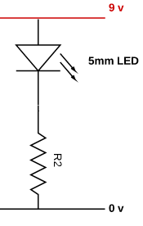

- Check out the diagram opposite. A Resistor is placed in series with the 5mm LED. Describe the purpose of the 330 Ohm resistor?  ___________________________________________________________________________________________________________________________________________________ | 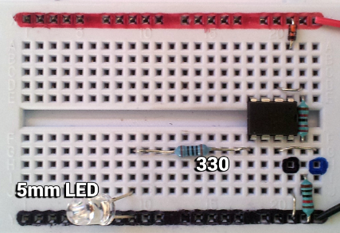
- Explain the effect of swapping the 330 Ohm resistor with a larger 1K Ohm resistor. Do this be researching and writing about the effect on the voltage across the LED with a large 10K resistor, the voltage across each component and the overall effect on the LED
_____________________________________________________________________________________________________________________________________________________________________________________________________________________________________________________________________________________________________________________________________________________________________________________________________________________________________________________________________________________________________________________________________________________________________________________________________________________________________________________________________________________________________________________________________________________________________________________________

Vocab list: voltage, shared, current, increases, decreases, same, brighter, dimmer, through, across

28 Technical Report | AS1.5
Achievement Standard 1.5 requires students to develop and test an electronics outcome and shows that they understand the purpose and function of components and interfaces.

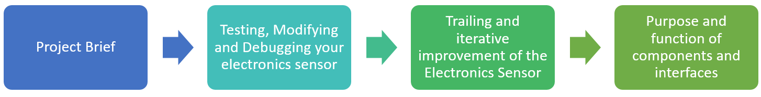

To be continued …

29 Workbook Answers

Microprocessors  1. Data and program storage, Input & Output control circuits, A central processing unit  2. Pin 3  3. Around 5v  Inputs, Processes & Outputs  1. Crossword includes these words: Thermistor, LDR, Buzzer, Decision, Motor, LED  2. Moisture Sensor or Temp sensor, On/Off Valve for water  Batteries | Voltage & Current  1, Voltage, volt, current, amp, cell, negative, positive  2. Voltage (V) measured in volt (v), Current (I) measured in Ampere (A)  4. 1.5v  5. 1.5v  6. AAA battery is smaller, contains less chemicals, does not last as long  Resistors  2. Ohms (Ω)  3. 1000Ω - 1kΩ, 2000Ω - 2kΩ, 4700Ω - 4.7kΩ, 12,000Ω - 12kΩ  5. Crossword includes these words: milli, ohm, battery, current, volt, ohm, kilo, voltage, cell  Series Circuit  1. 2.0v  2. 2.5v  3. 25mA  4. 2.7v  LED Characteristics  2. From 1.8v Up to 3.2v  3. LED may overheat and burn out  Transistor Switch  3. Motor spins in the reverse direction  5. Digital output pin cannot supply enough current  6. Voltage applied to base pin  Button Interface  2. Pull the digital input in to LOW | Light Sensing Interface  1. Intense Light - Low readadc value like 0-10, Darkness high readadc value like 200-255,  5 Crossword include: megaohm, LDR, multimeter  Temperature Sensing Interface  1. Thermistor resistance decreases, so readadc value will also decrease  Make decision with code  1. File name, title, code comments, indentation, variable assignment  2. Giving a variable a meaningful name to reuse in the program  3. Descriptions of what the code is doing  4. LDR so Light  5. Take in and store input, process input and turn on output device  6. Closed  7. Code will ‘do something else  Voltage, Current, Resistance Review  1. Amp  2. 0.01A, 0.025A, 0.110A  3. Ohm  4. 330, 470, 1K, 10K, 4K7, 10K  5. Heat  Voltage Divider  1. 2  2. Series  3. Large  4a. 5V  4b. 1M, 1Mega Ohm resistor  5. An integer between 0-255  Processing a voltage signal  1. Analogue to Digital Conversion  2. Input Pin and Variable  3. 255  4. Sends data to the PC  Ohms Law  1. R=V/I = 4.5/.1 = 45 Ohms  2. I=V/R = 3/60=0.05 Amps

Component review
1. 5.0v
2. 110mA
3. 5v
4. 55mA
5. Between 1.8v and 2.2v
6. 20mA
7. Overheat and burn out
Current Limiting Resistor
1. To reduce the current to the LED and to reduce to voltage across the LED
2. 9v - 1.8v = 7.2v | R=V/I = 7.2/0.02 = 360 Ohms
3. To reduce the current to the LED and to reduce to voltage across the LED
4. The larger 1K Ohm resistor will reduce the current to a very small value and reduce the voltage across the LED to a value below that needed to make the LED glow

