Teacher Guide: Programme 2

Digital media: Web

These notes should support you to teach the digital media teaching and learning programme.

The ePub can be accessed in a number of ways. One option is to right click on the file and choose ‘open with’ and then ‘FireFox’ (or Edge). This *should* allow the ePub to be displayed. If you are not a BYOD school, please experiment with your lab computers to check that the ePub can be accessed by students. If you going this route, students can access the table of contents as follows…

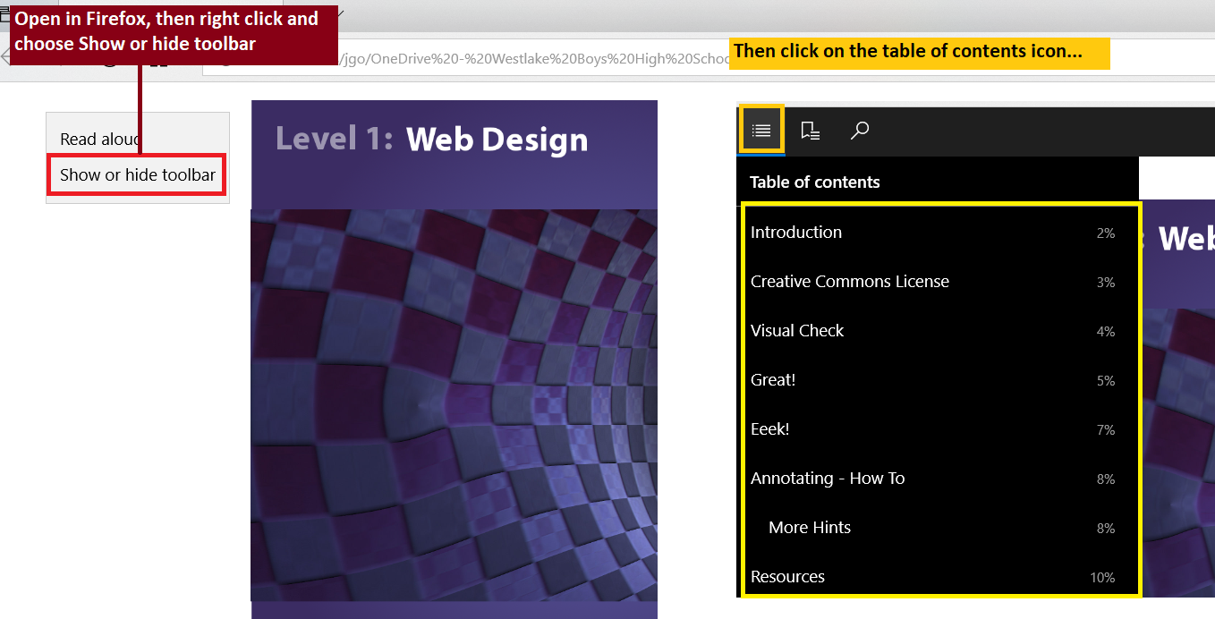

An alternate option (ideal if you are a BYOD school) is to access the ePub via a reader such as Readium (a chrome add on), Qiu Reader (a really good Mozilla add on) or iBooks. These will allow students to easily access the material and it will automatically keep their place. These options also allow students to easily show (or hide) the table of contents.

Students should be encouraged to watch the videos in the ePub at least once so that they know what to do. All of the videos have sound and close captioning - the vast majority of students will probably find listening to the videos really useful. You may need to explain to some students that they should watch between 10 and 15 seconds of video and then copy what they see.

The folder called “Teacher_Answers” contains two sites. The one called ‘11_Book_Fan’ matches the videos provided. The second, called ‘11_Web_Original_2018’, includes code and a spreadsheet (in the 00_Raw_Assets folder) which allows students to create a searchable list of libraries on the front page sidebar using javascript. It also has a custom contact form. Both of these features go well beyond the scope of the standard but if you have exceptional students, you could use this as inspiration for extending the task. I have not created any videos / guide showing how to implement the Javascript / create the custom contact form.

Important: The ‘model answers’ show one possible design for the site. I would expect student practice work to look quite different. Students should be encouraged to choose their own colours, images and fonts. They are also welcome to change the site layout if they wish (as long as their proposed layout is a workable solution).

The eBook includes several purple coloured boxes which encourage students to experiment and create sites which are significantly different from the site shown in the eBook.

Copyright: The ePub also contains pages dealing with copyright for text and images. Teachers might want to discuss this in class with students. The short version is that students need to be reminded that copying / pasting text from an external source is not OK. Text can either be supplied or students can generate it themselves. If students do choose to use text from an external source, the eBook advises them to paraphrase and cite.

In the support files area, there is a documentation template. I’ll be encouraging my students to make copies of this template and complete it both for the practice and assessment tasks.

In their documentation students should make notes / justify any major decisions / changes related to how their site has been refined. They don’t need to screenshot every single step of the process but they should be able to show how they have refined their site by provided ‘before’ and ‘after’ screenshots at key points. If they ask which way to do something, please encourage them to trial both ways and then choose the best option - they will want to take screenshots showing they have done this as it forms part of the evidence needed to get an M / E grade. The emphasis in the documentation is to show that the site has been tested and refined. Justifications should be less than three sentences long! Most of the documentation will be taken up with large (hopefully easy to read) screenshots. Feel free to remind students that they can submit screencast / video evidence if they prefer.

The resource uses HTML, CSS and some php server side includes. To get the php to work, students will need to have access to a suitable environment - either XAMPP / local host or a hosting area where they can upload their html / php and then test that it works.

In the eBook, there are three checkpoints where it is hoped that students will submit their partial websites / documentation. The suggested checkpoints are as follows:
- Checkpoint 1 - Index Page
- Checkpoint 2 - Contact Page (ie: partial site which now includes a working contact form)
- Checkpoint 3 - Complete Page and documentation

Hopefully most students will manage to complete checkpoint 3 before they attempt the assessment. Ideally we would want to give them feedback on what they have so that if there are any issues, they can be fixed / avoided in the assessment.

