Instruction sheet for sheep reaction times.

URL for sheep reaction times: http://www.bbc.co.uk/science/humanbody/sleep/sheep/reaction_version5.swf

Screen that comes up when you first enter the website. Click on the go button to start.

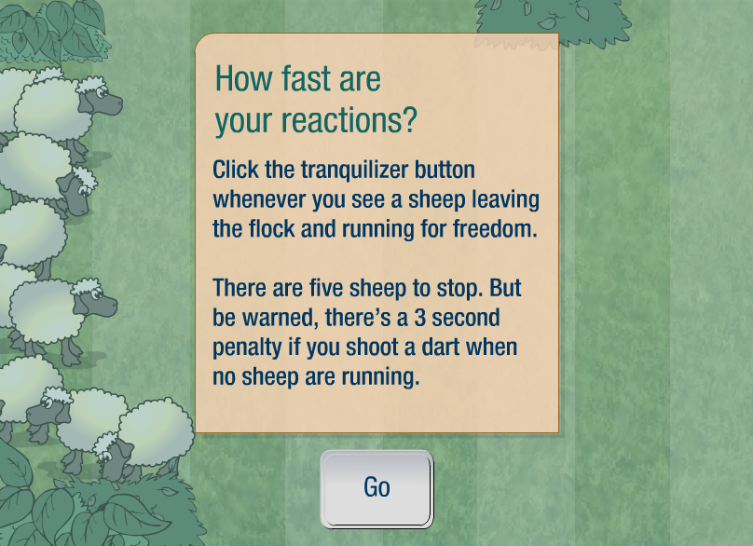

Line up the mouse over the tranquilliser button to stop the sheep. You only need to click the button, not aim at the sheep.

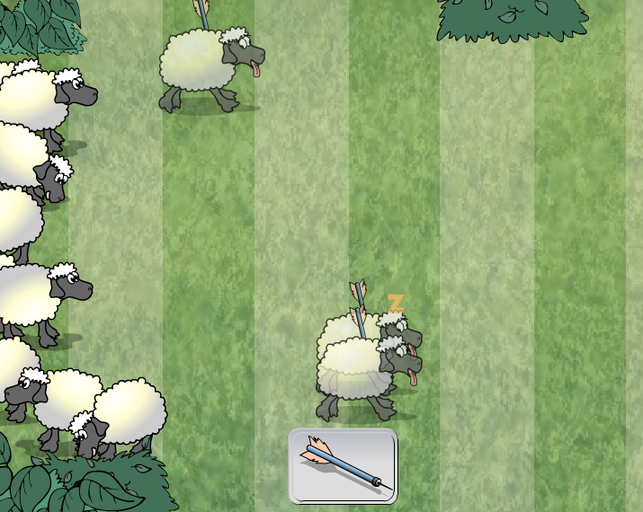

As you are successful at hitting the sheep they stop. After five goes the activity stops and a summary of the five sheep is given along with an average for all five sheep and a description of your ability to react.

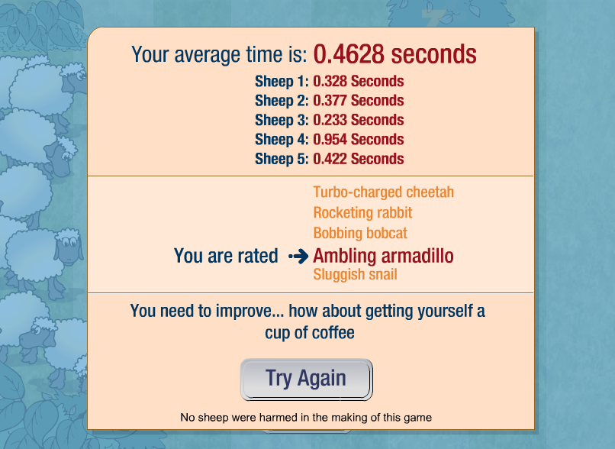

Record the five times beside the sheep in the order that they happen.

Sometimes you might jump the gun. Click on continue and then keep going for the current trial.

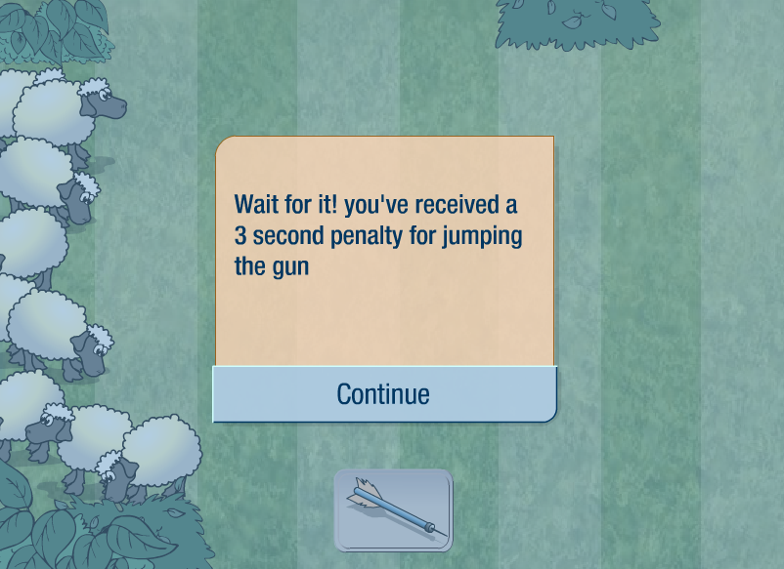

Record results the same as previously, except this time you will have some at 3 seconds depending in how many times you have jumped the gun.



