Sleeping sheep or are you a turbo-charged cheetah?
Level 6
Focus:comparison
This activity involves using a website shockwave flash activity to collect student reaction times.

Students to design aspects of the investigation within the boundaries.

URL for sheep reaction times: http://www.bbc.co.uk/science/humanbody/sleep/sheep/reaction_version5.swf

 | Teacher activity/dialogue |  | Possible student outcome/dialogue
Problem   | Do I have a faster reaction time than X?  Make a prediction. |  | Why might fast reaction times be important?  Generally, and then specifically in using the computer.
Plan  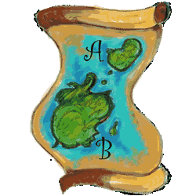 | In this part of the cycle students need to think about how they might test to see who has the faster reaction time.  Things to consider:  How they will measure reaction time – use the sheep reaction time activity.  How many measures will they take?  Will they allow a practice run?  How will they deal with penalty shots?  How do we know everyone has done the same trialling?  It maybe worthwhile to let them have an explore with the activity for five minutes and then discuss further how the experiment migh work. Other ideas include giving students extended time to explore the activity and come up with the plan. |  | http://www.bbc.co.uk/science/humanbody/sleep/sheep/reaction_version5.swf provides an interactive shockwave flash activity whereby the players have to tranquilize sheep as they leave the pen. Details on how the game works are below.  In trialing this task, some students just ignored sets of data where they had scored 3.0 penalty times. This meant that it took a little longer but more importantly the data then wasn’t reliable as not everyone had performed under the same conditions.
 | 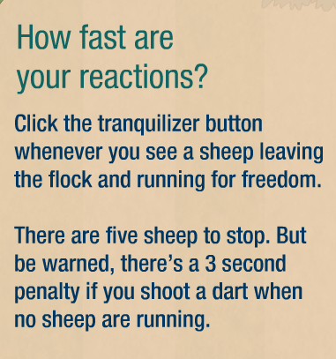 |  | 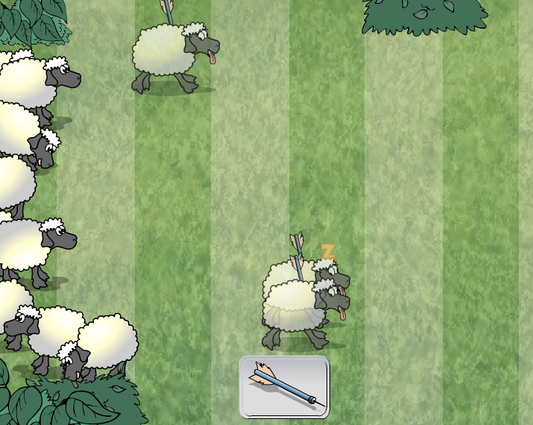
Suggest that they do the activity once just to get a feel for how it works.
Maybe they might collect 30 pieces of data, do the activity 6 times.
At the end of each set of five sheep the reaction times for the five sheep are given.

Data  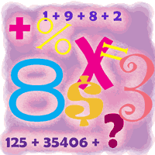 | 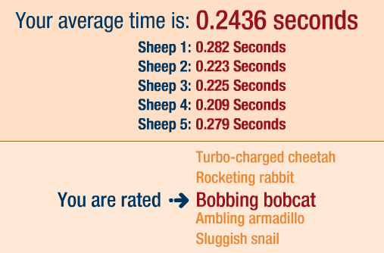 |  | Students to play the game six times and record the five results each time. Total 30 results. It is not necessary to record the average time. Important to keep the trials in order from 1 – 30.  Follow up the data collection with feedback on how they found it. Were there any strategies they employed, eg covering the bobbing sheeps head.
Analysis  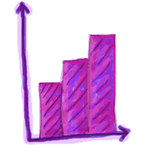 | Once the students have collected their 30 pieces of data and their friend’s 30 pieces of data they can draw graphs and write descriptions of what they notice.  The first graph to draw is a observation plot. This is simply a time series type graph where the observation number (trial number) is along the x axis and the time taken is on the y axis.  From this observation plot you want to see if there is any pattern to the trials. For example it might be that there is clearly a pattern of improvement, that is with practice the times are improving, or is the plot random, that is there is not an improvement happening so the 30 trials could be considered a sample and therefore it is possible to make a generalisation about the population of interest, which in this case would be the reaction times of the person.  Once the students have had a look at the observation plot and they are happy that the data appears to be a “random” sample of the person’s possible reaction times they can now draw plots to start to compare the two sets of reaction times.  Initially students should draw a dot plot of their data and describe it. This will be very similar to the observation plot, except that the values that are the similar are clearer.  Students should be noticing things about summary statistics (median, maximum and minimum values, mode or modal group if appropriate), shape of the distribution, spread of the distribution, middle 50% of the data.  From the dot plot or otherwise students can find the five number summary statistics. Minimum, maximum, median, upper and lower quartiles.  This information can help to draw a box plot of the data. At this stage the students should be combining their box plots in order to make the comparisons. It is important to keep the dot plots and students might like to draw the dot plot and then draw the box plot on top.  At this point students should have two box plots to compare. Comments about the difference and similarities of the two plots should include shape, spread, middle 50% of data, and summary statistics.  Combined data: |  | This plot shows a “random” pattern of results for reaction times. There appears to be two reaction times that are particularly slower than the others.  By drawing two lines along the plot it shows that almost all the reaction times are between 0.19 and 0.37.  The dot plot shows a similar pattern to the observation plot, that is nearly all of the reaction times lie between 0.19 and 0.37 seconds, but more importantly the middle group of reaction times is between 0.24 and 0.31 seconds. The reaction times are clumped together tightly between 0.19 and 0.3 seconds and more spread out from 0.3 to 0.485 seconds. This also shows that the reaction times are slightly skewed to the right. The median reaction time is approx 0.27 seconds. There is one reaction time that is quite a bit higher than the others at 0.485 seconds and one at 0.433 seconds.  Partner’s data  The reaction times for my partner seem to be more clustered than my reaction times. Their median reaction time is approx 0.02 sec faster than mine and their mean reaction time is approx 0.04 sec faster than mine. The middle 50% of their box plot is shifted to the left more than mine. The upper quartile of reactions times for my partner is lower than the median for me.
Conclusion   | The conclusion should be done. Here the students answer their question and provide supporting evidence from their analysis. | Based on these data I would conclude that my partner’s reaction time is slightly faster than mine. 75% of her reaction times are faster than 50% of my reaction times and her mean 0.244 is faster than my mean of 0.281.  I think that generally her reaction time will be faster than mine as I think these results probably fairly reflect our reaction times. There was no obvious improvement over time.
Reflection | What sort of things could you reflect on as a teacher for this activity, as a student for this activity? Rounding results to 2dp to graph is this a good idea? Data collection, did they include the 3.0 results or just ignore these? Does it matter? Was it important for both people to have the same sample size to make the comparison?
Extension activity | Explore other reaction activities – see if different people are better a different ones.  http://www.serendip.brynmawr.edu/bb/reaction/reaction.html gives four different reaction activities.  Time series investigation – have you improved over time? Collect more results. Could use as an introduction to time series.  Average times – what average time to be a bobbing bobcat?  Comparison across genders – collect averages…

A set of reaction times to use if needed for comparison.  These were collected using one practice and then the next 30  results were recorded. It is true there was no jumping the gun in these trials.  Read from left to right and then down.  The analysis provided in this task is based on these results. | 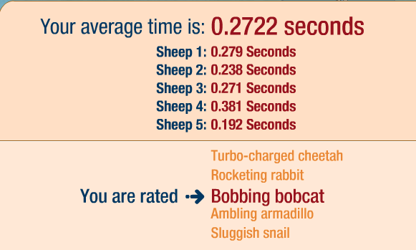
 | 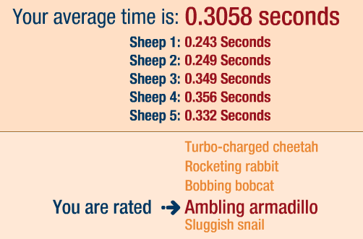 | 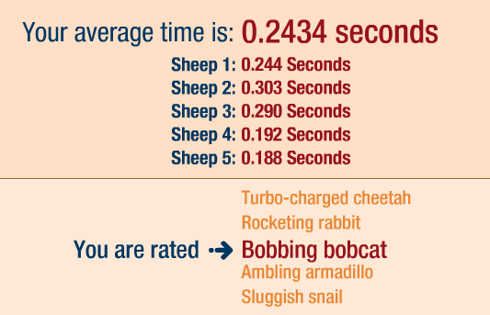
 | 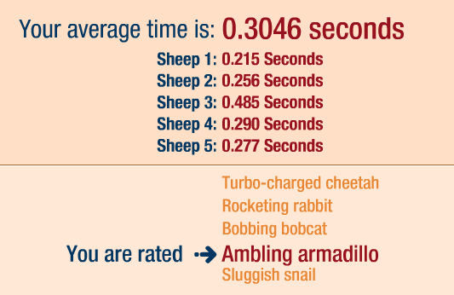 | 

